Practical 8
1. Aim
To configure Remote Desktop Services (RDS) on an already installed Windows Server 2025 virtual machine, publish an application using RemoteApp, and access the application remotely through RD Web Access from a Windows 11 client.
2. Software and Hardware Requirements
- Host operating system: Windows 11 Home (64-bit)
- Server operating system: Windows Server 2025
- Virtualization software: VMware Workstation Pro
- RAM: 8 GB or more on the host is recommended
- Virtual disk: Existing Windows Server virtual machine with sufficient free space
- Network: VMware virtual network allowing communication between the host and server
- Client software: Web browser and Windows Remote Desktop client
3. Theory
Remote Desktop Services (RDS) is a Windows Server technology that allows users to access applications and desktops hosted on a remote server.
The main components used in this practical are:
- RD Session Host: Hosts applications and remote user sessions.
- RemoteApp: Allows individual applications to be published and accessed remotely without requiring users to work with a complete remote desktop.
- RD Web Access: Provides a web portal through which authorized users can view and launch published applications.
- RD Connection Broker: Manages connections to remote desktops and applications.
- RD Licensing: Manages Remote Desktop Services Client Access Licenses (RDS CALs) in a properly licensed deployment.
In this practical, Windows Server 2025 runs as a virtual machine in VMware Workstation Pro, and Windows 11 acts as the client. A sample application, Notepad, is published through RemoteApp and accessed using RD Web Access.
4. Procedure
Step 1: Start the Windows Server Virtual Machine
- Open VMware Workstation Pro on the Windows 11 host.
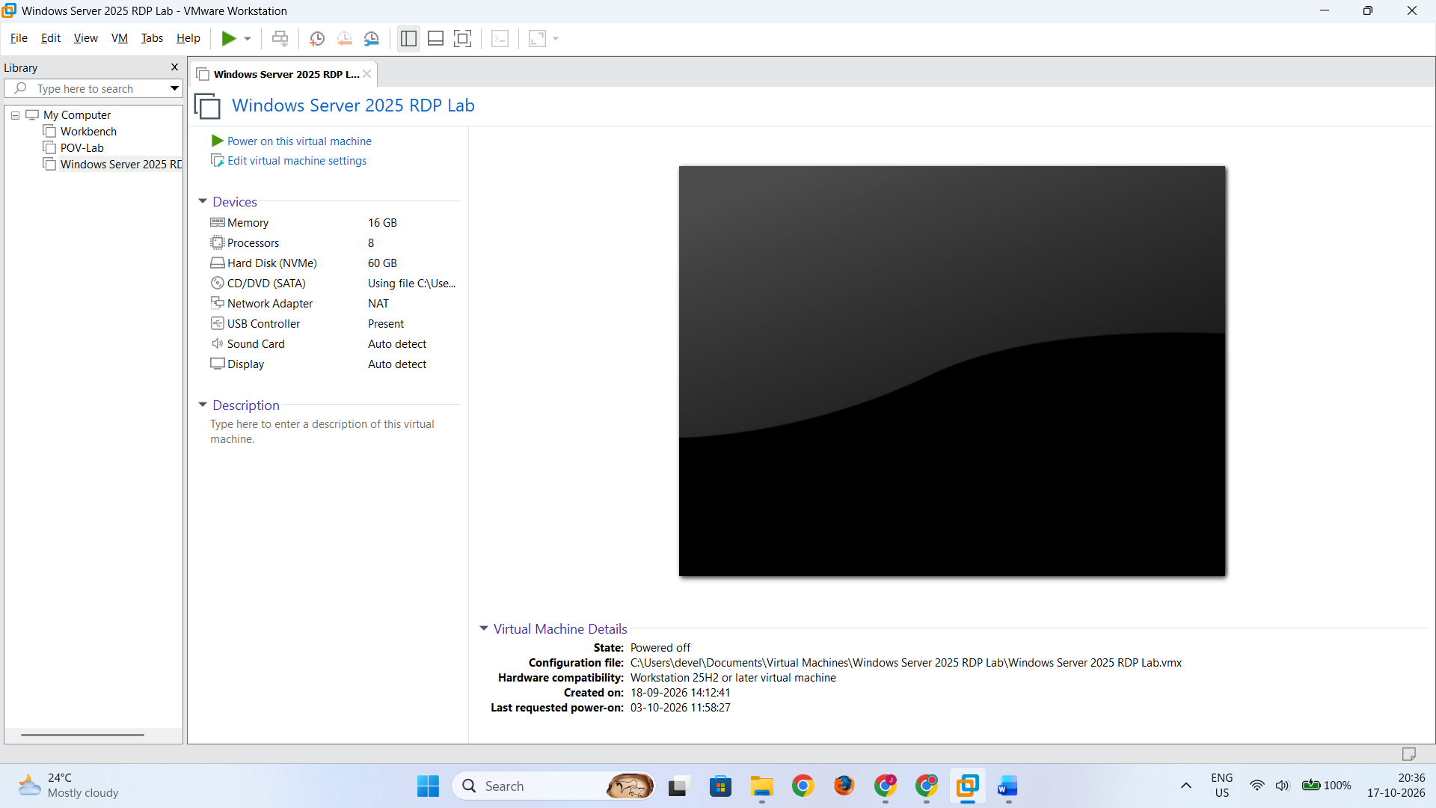
- Start the previously installed Windows Server 2025 virtual machine.
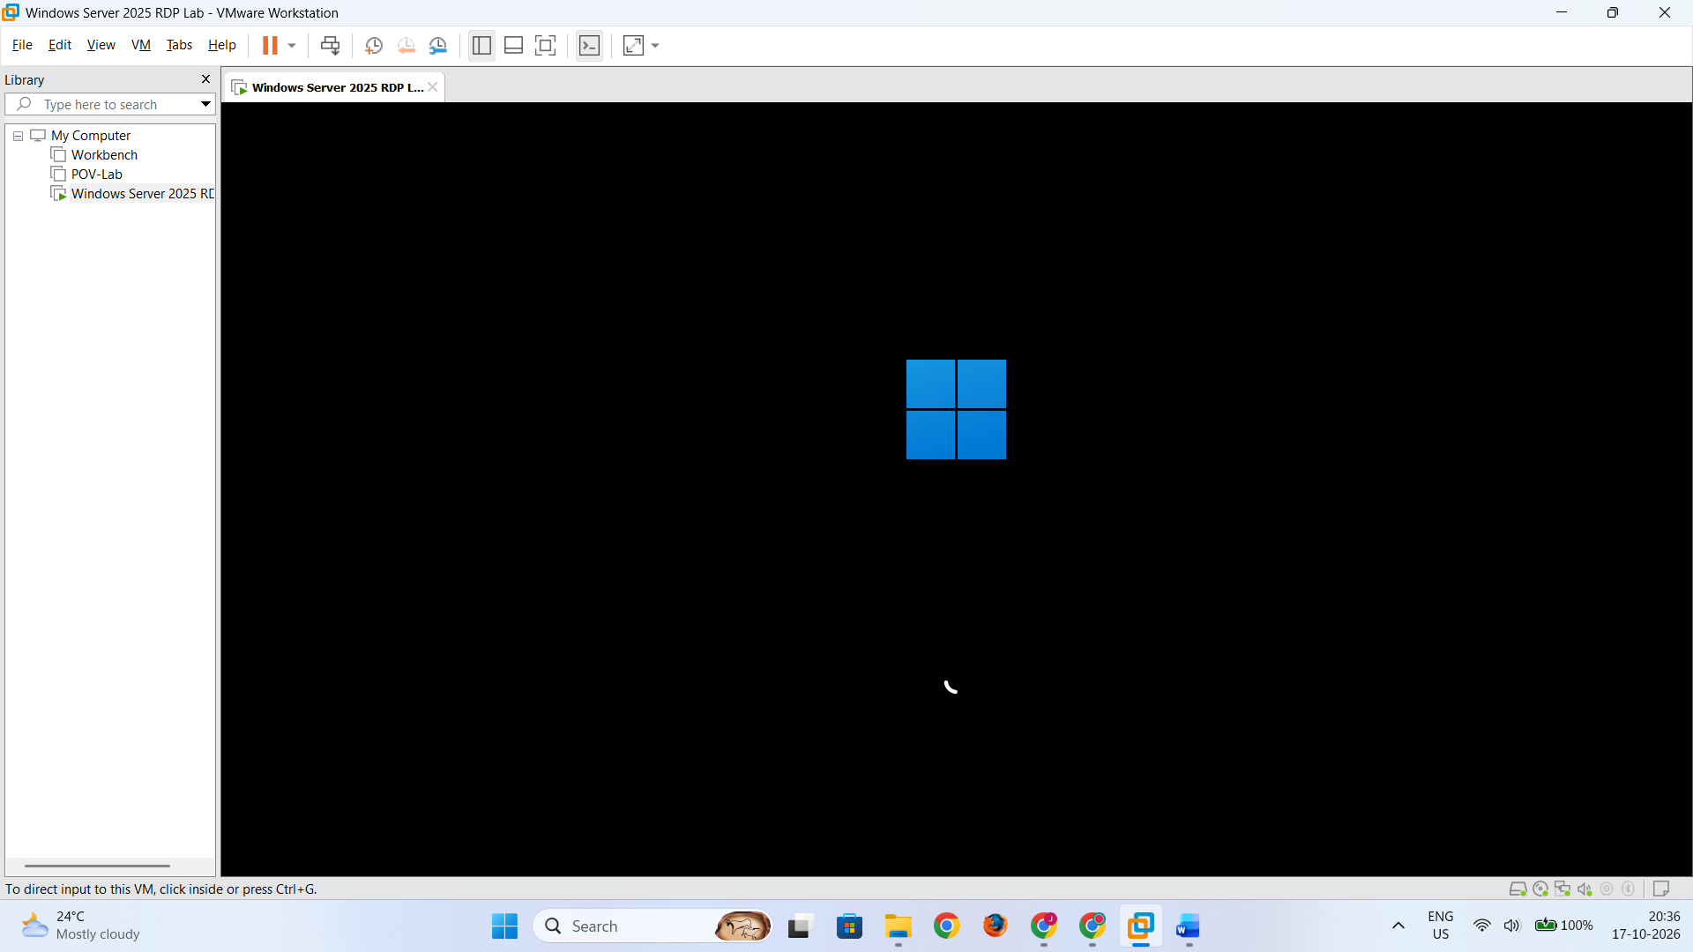
- Log in using the Administrator account.
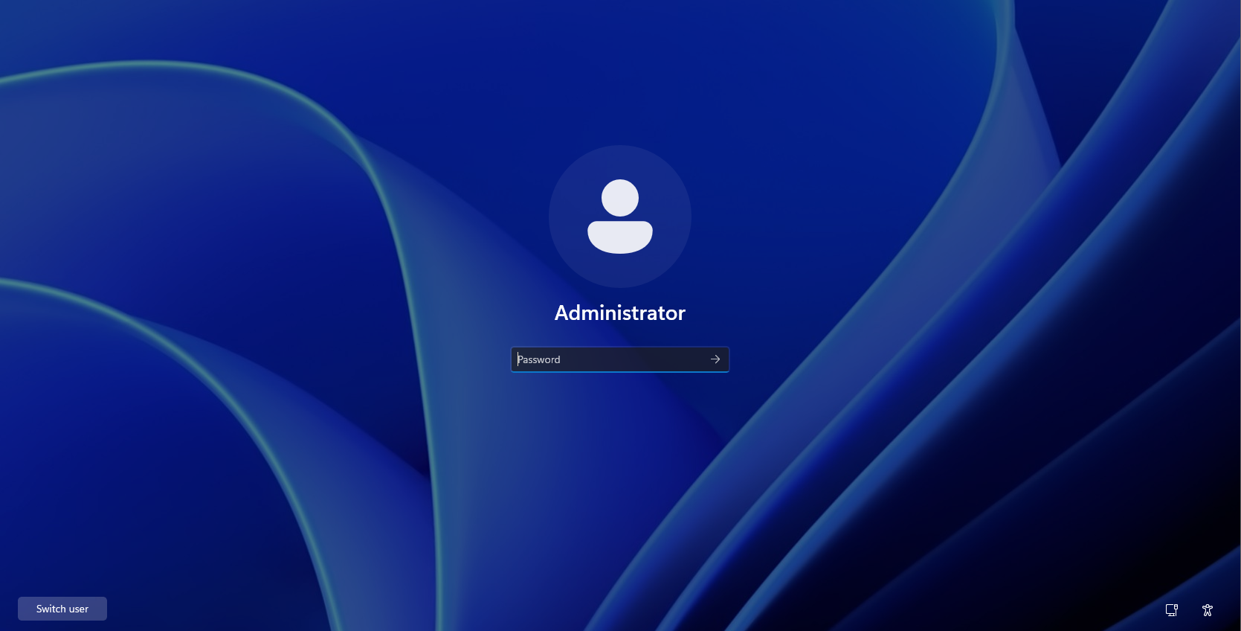
- Open Server Manager.
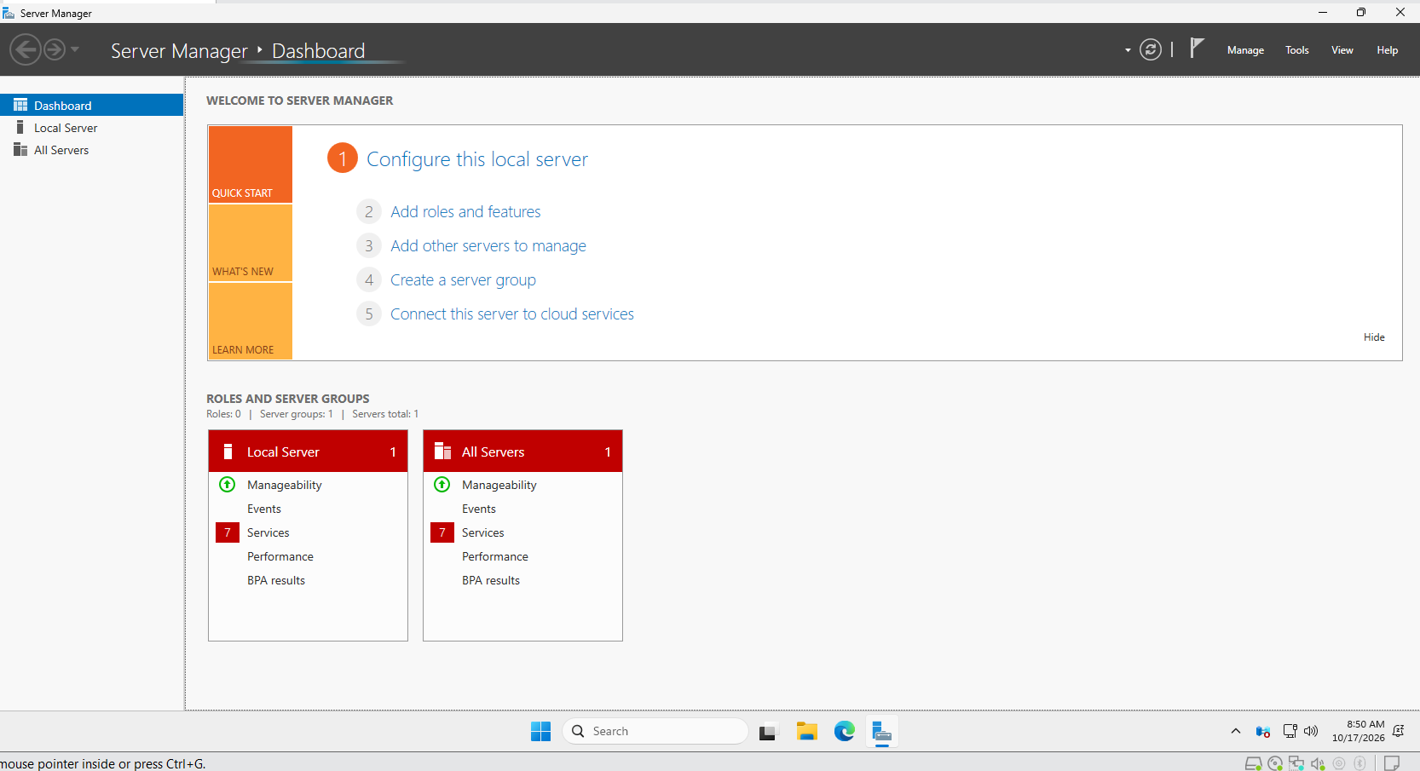
- Note the server's computer name and IP address.
- Open Command Prompt and execute the following command:
ipconfig
- Record the IPv4 address of the server.
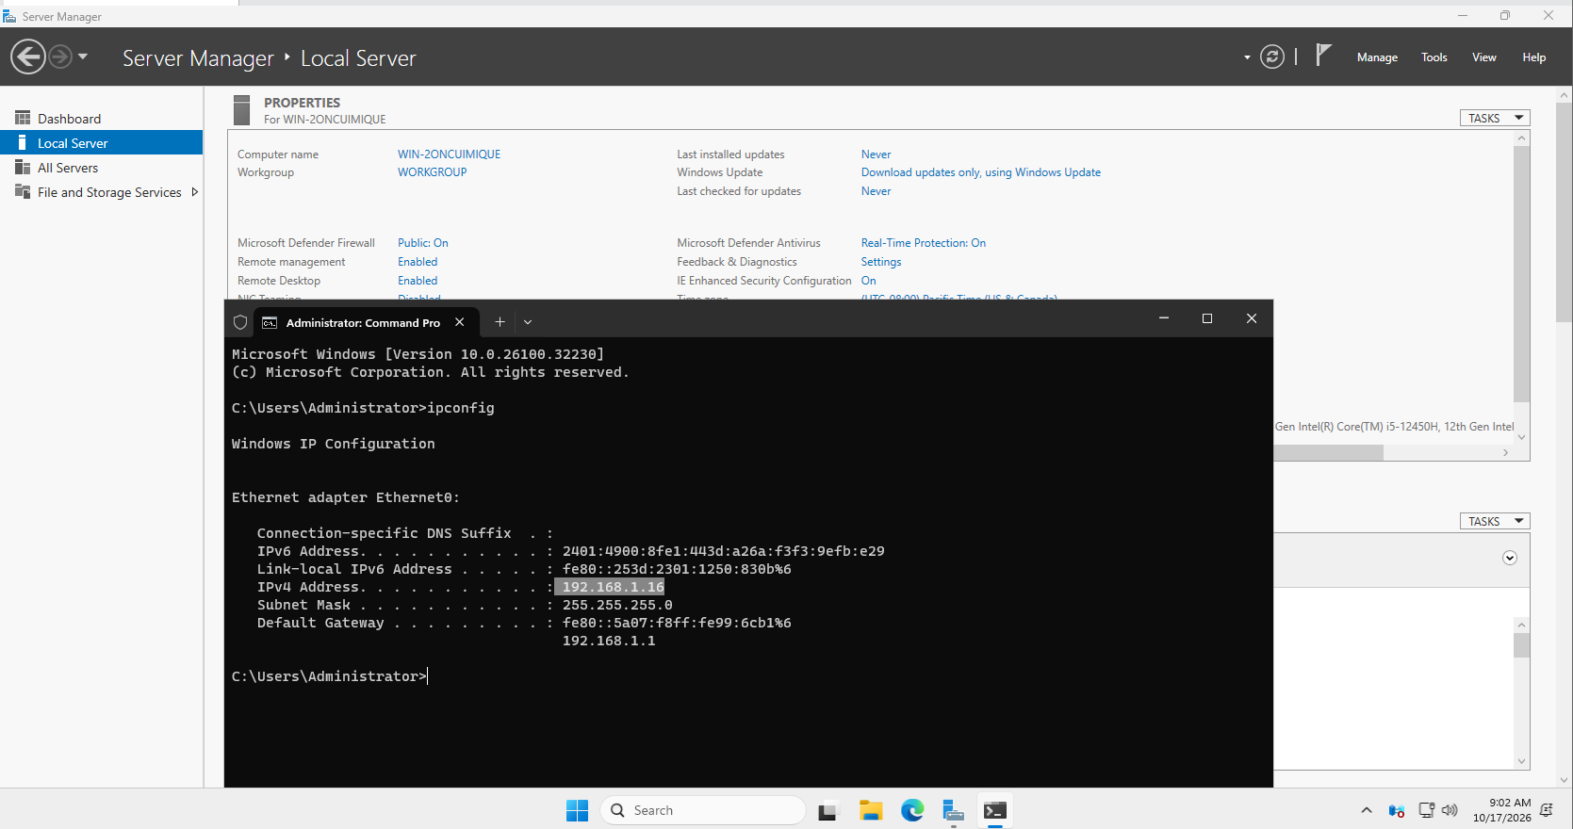
- Verify that the Windows 11 host can communicate with the server over the configured VMware virtual network.
Step 2: Configure the Network
- In VMware Workstation Pro, open the virtual machine settings.
- Verify that the network adapter is enabled.
- Select Bridged networking as the network connection for the Server VM.
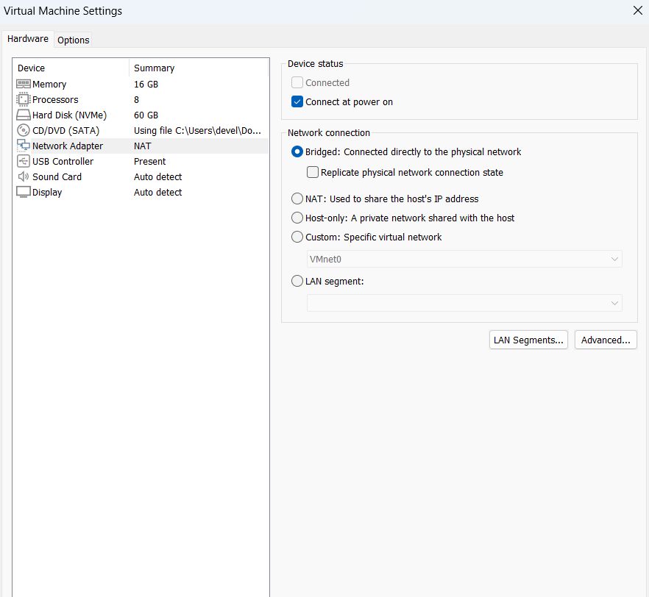
- Start the server and verify its IP address using ipconfig.
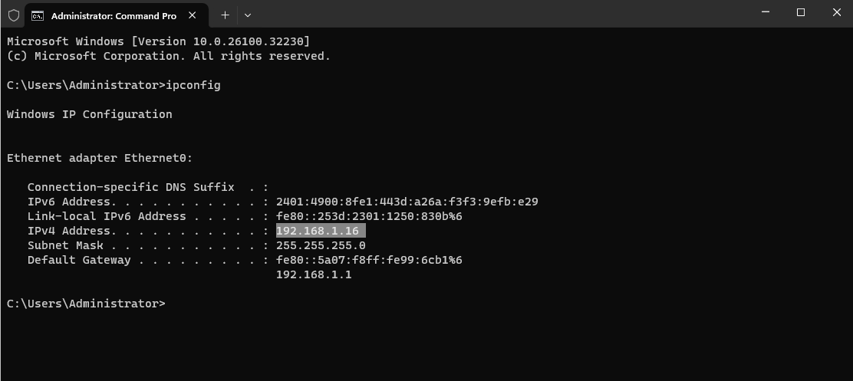
- From the Windows 11 host, open Command Prompt and execute:
ping <server-ip-address>
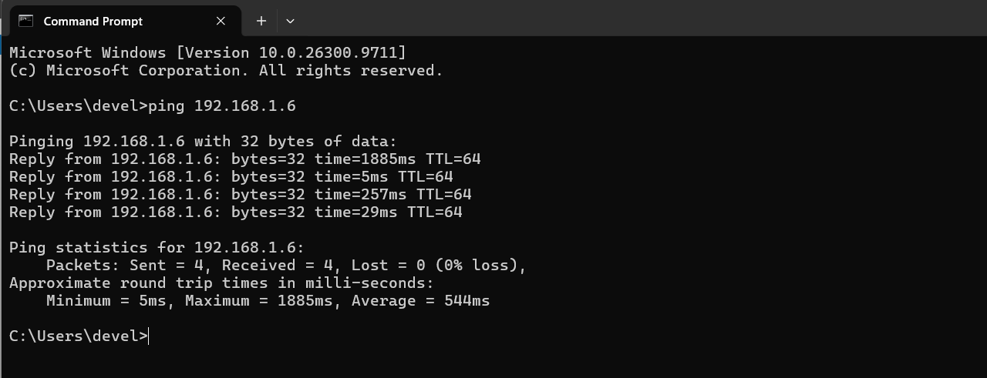
- Verify whether the server responds. If ping fails, check the network configuration and firewall rules before proceeding.
Step 3: Configure Active Directory Domain Services
A domain-based RDS lab can use Active Directory Domain Services (AD DS) for user authentication and access management. If a domain controller and domain have already been configured in a previous practical, use the existing configuration and proceed to Step 4.
If the server is not yet a domain controller:
- Open Server Manager.
- Select Manage → Add Roles and Features.

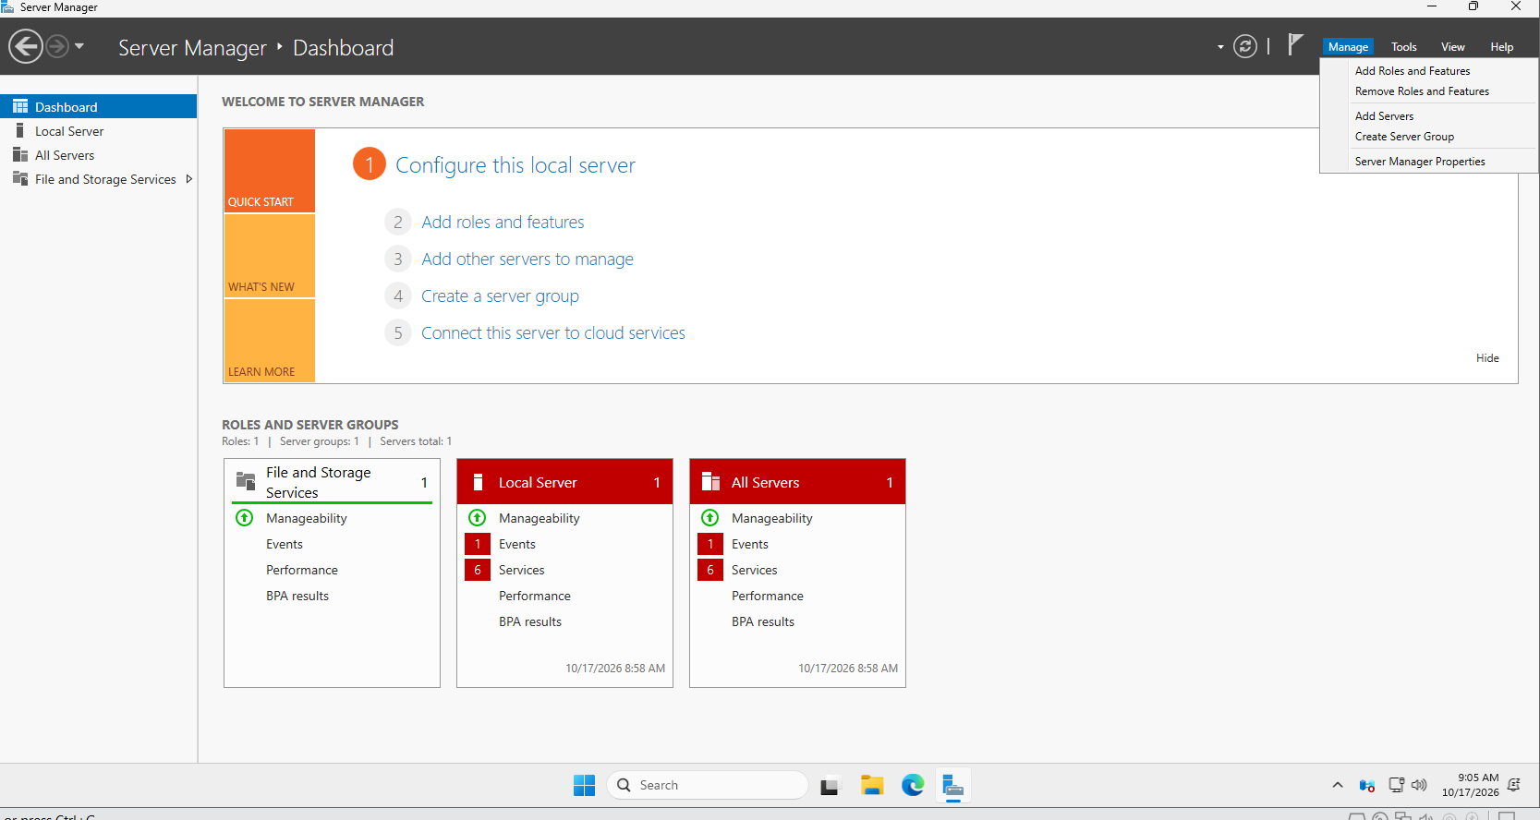
- Choose Role-based or feature-based installation.
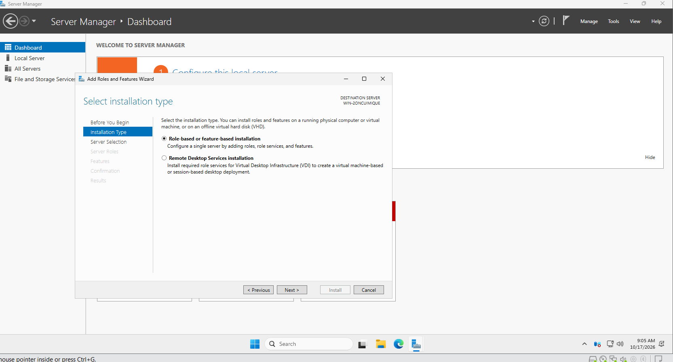
- Select the Windows Server 2025 machine.
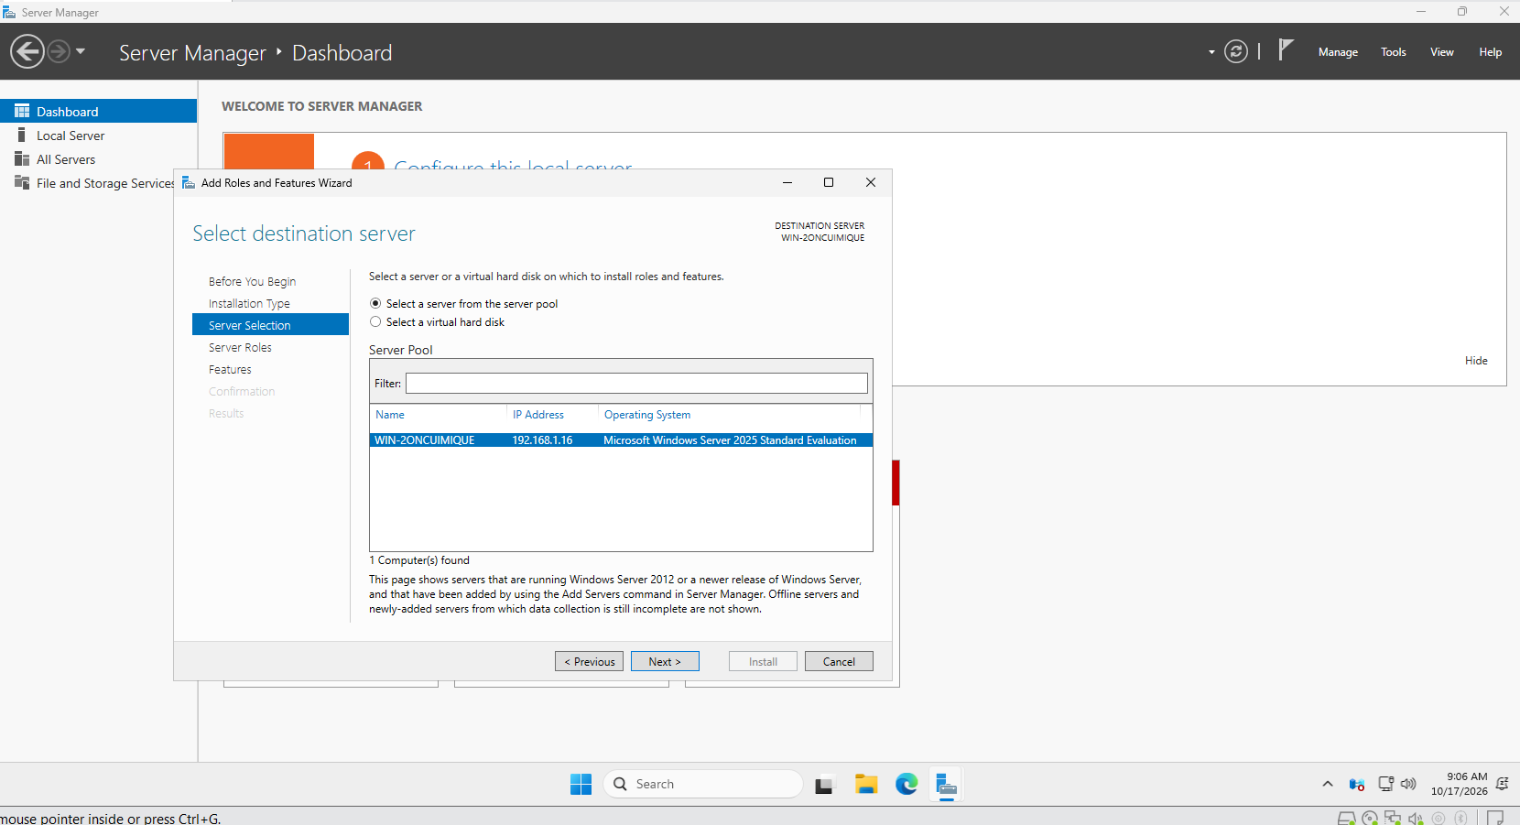
- Select Active Directory Domain Services and add the required features.
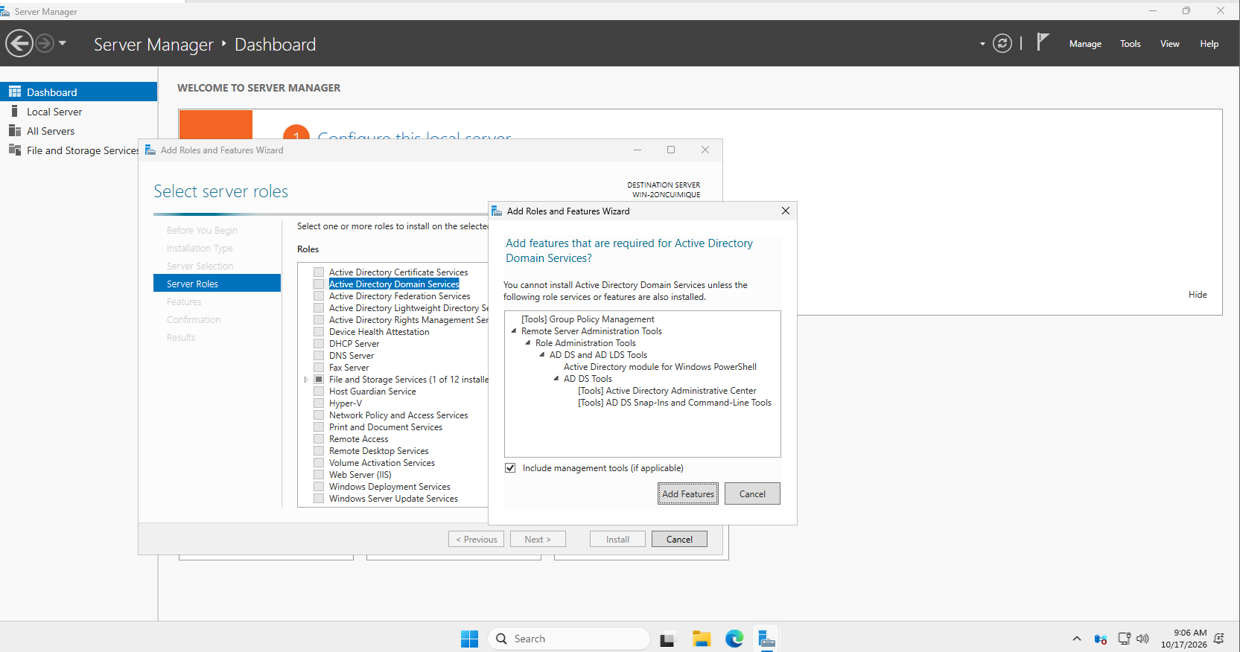
- Complete the installation.
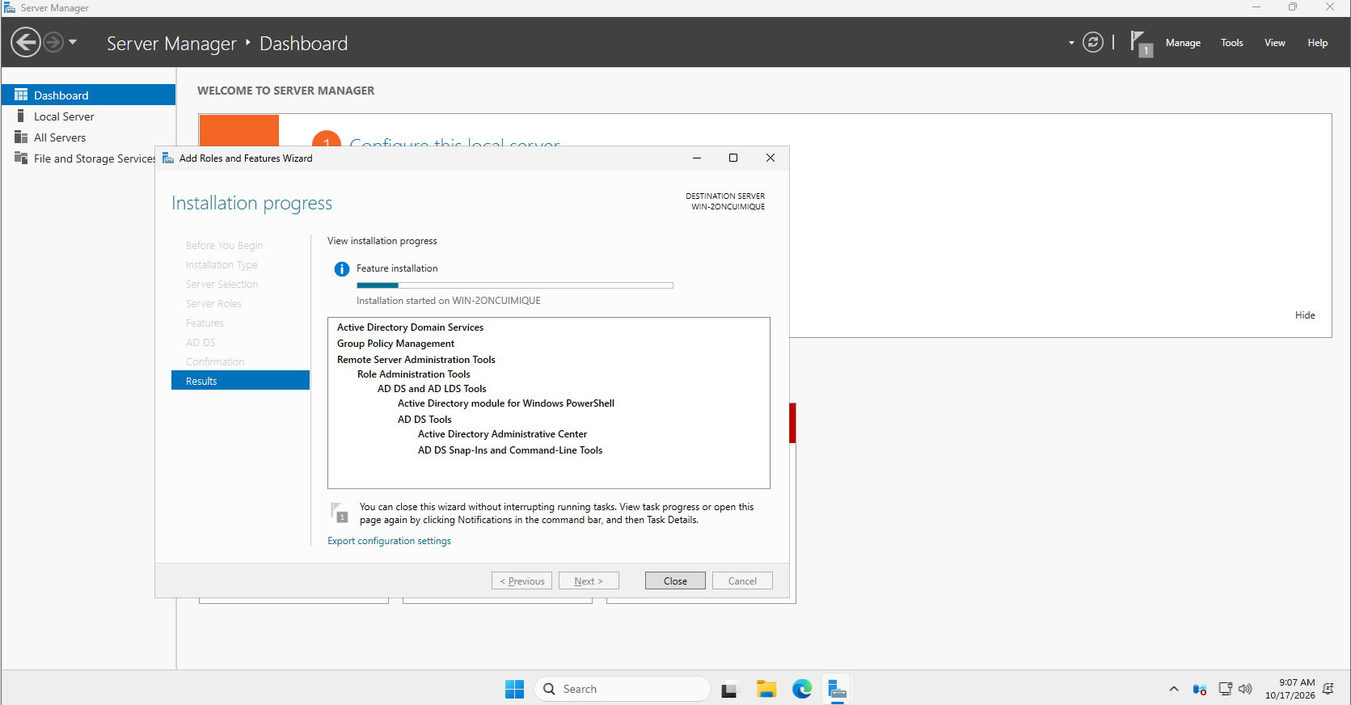

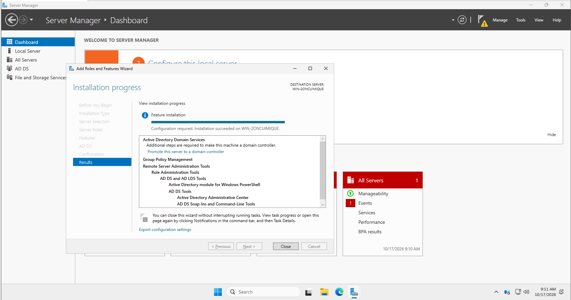
- Click the notification flag in Server Manager and select Promote this server to a domain controller.
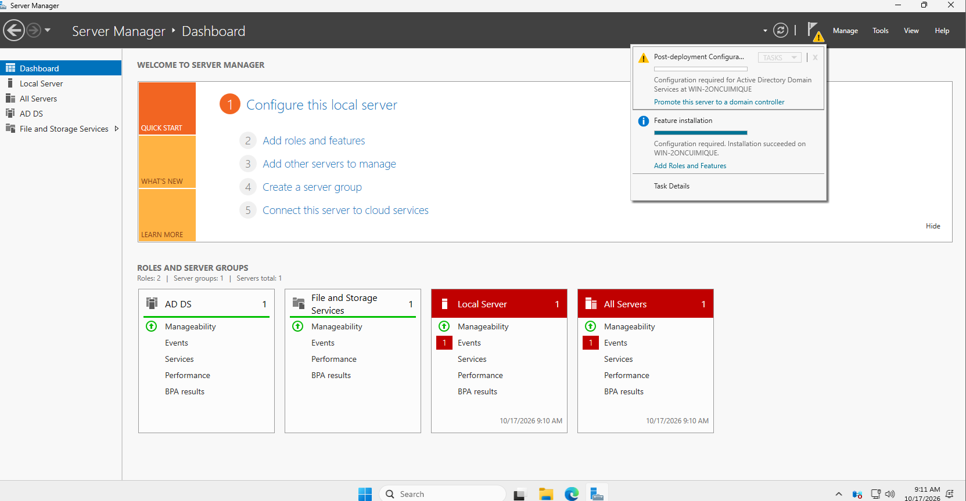
- Select Add a new forest and enter a lab domain name, such as lab.pov.com.
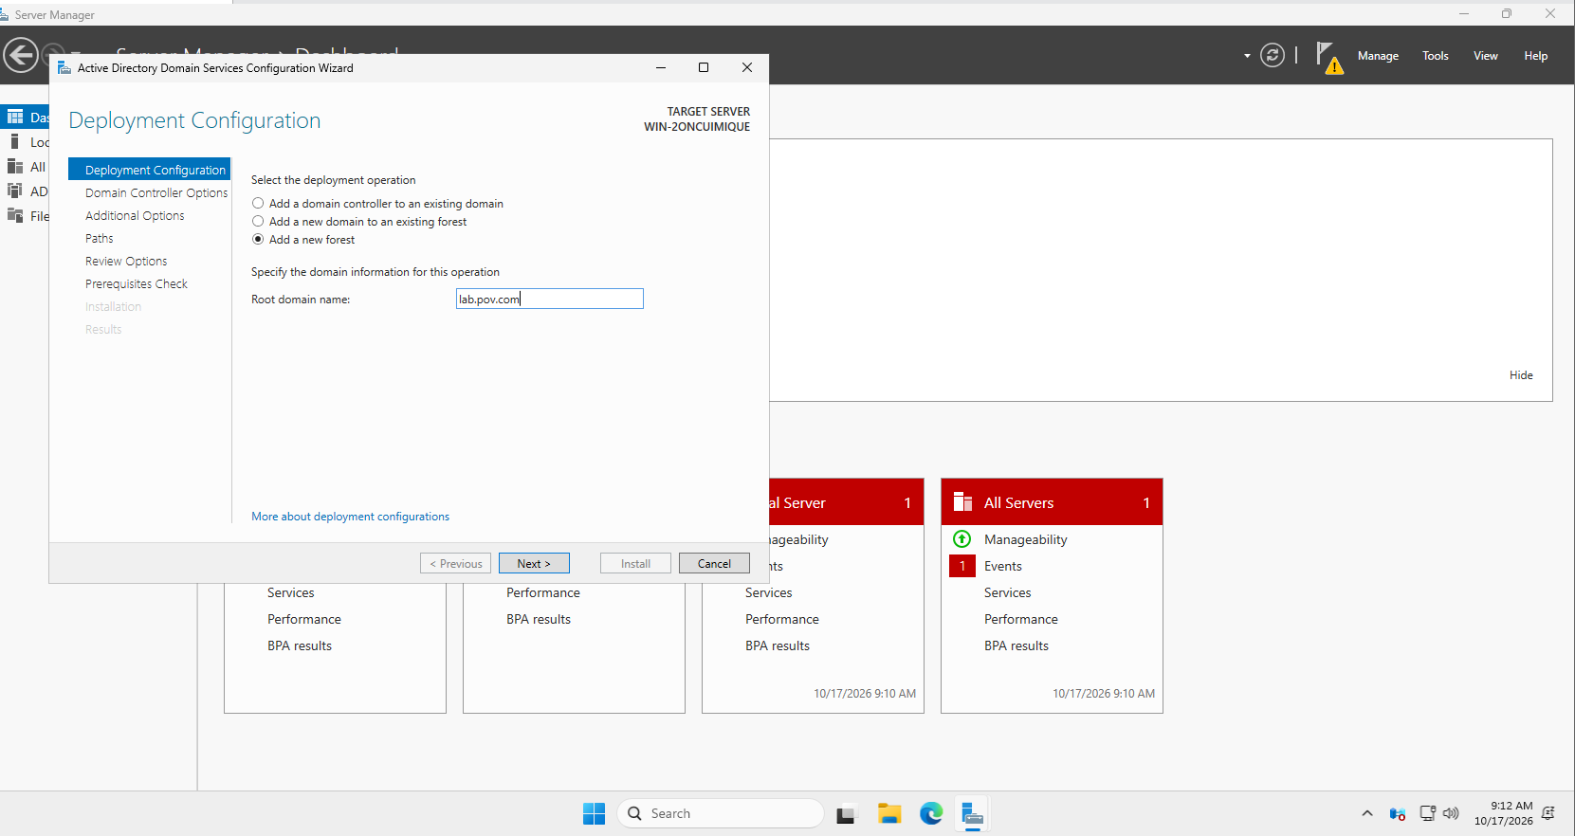
- Configure the required Directory Services Restore Mode password.
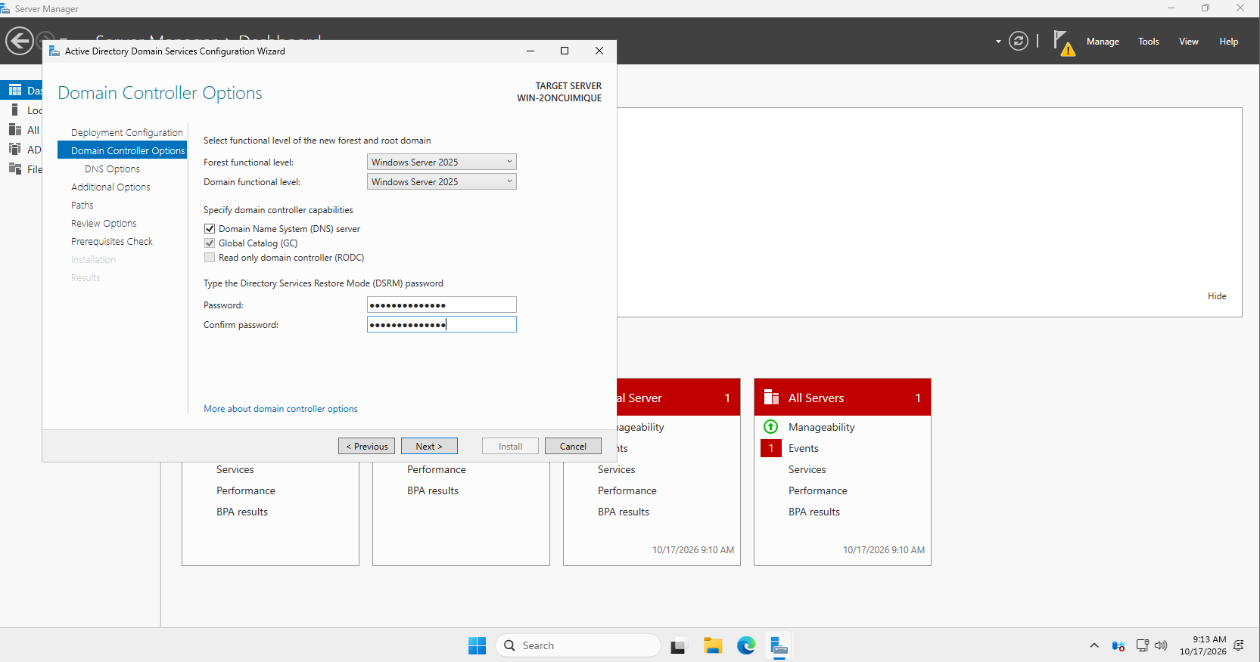
- Complete the wizard and restart the server when prompted.
- Log in using the domain Administrator account.
For a basic classroom lab, the same VM may be used for learning purposes, although production environments should separate domain controller and RDS roles.
Step 4: Create a User Account
- Open Server Manager.
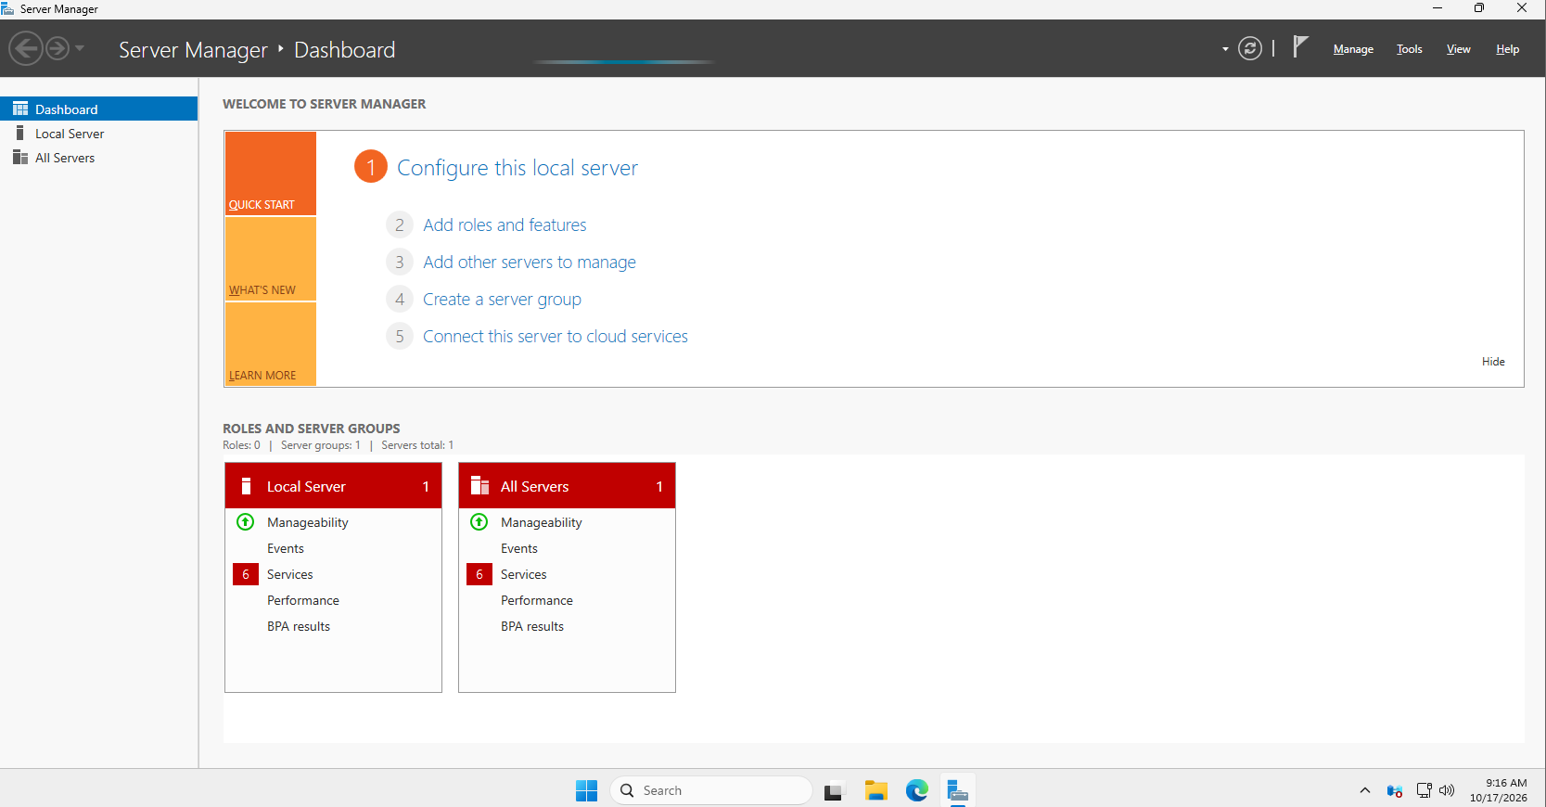
- Select Tools → Active Directory Users and Computers.
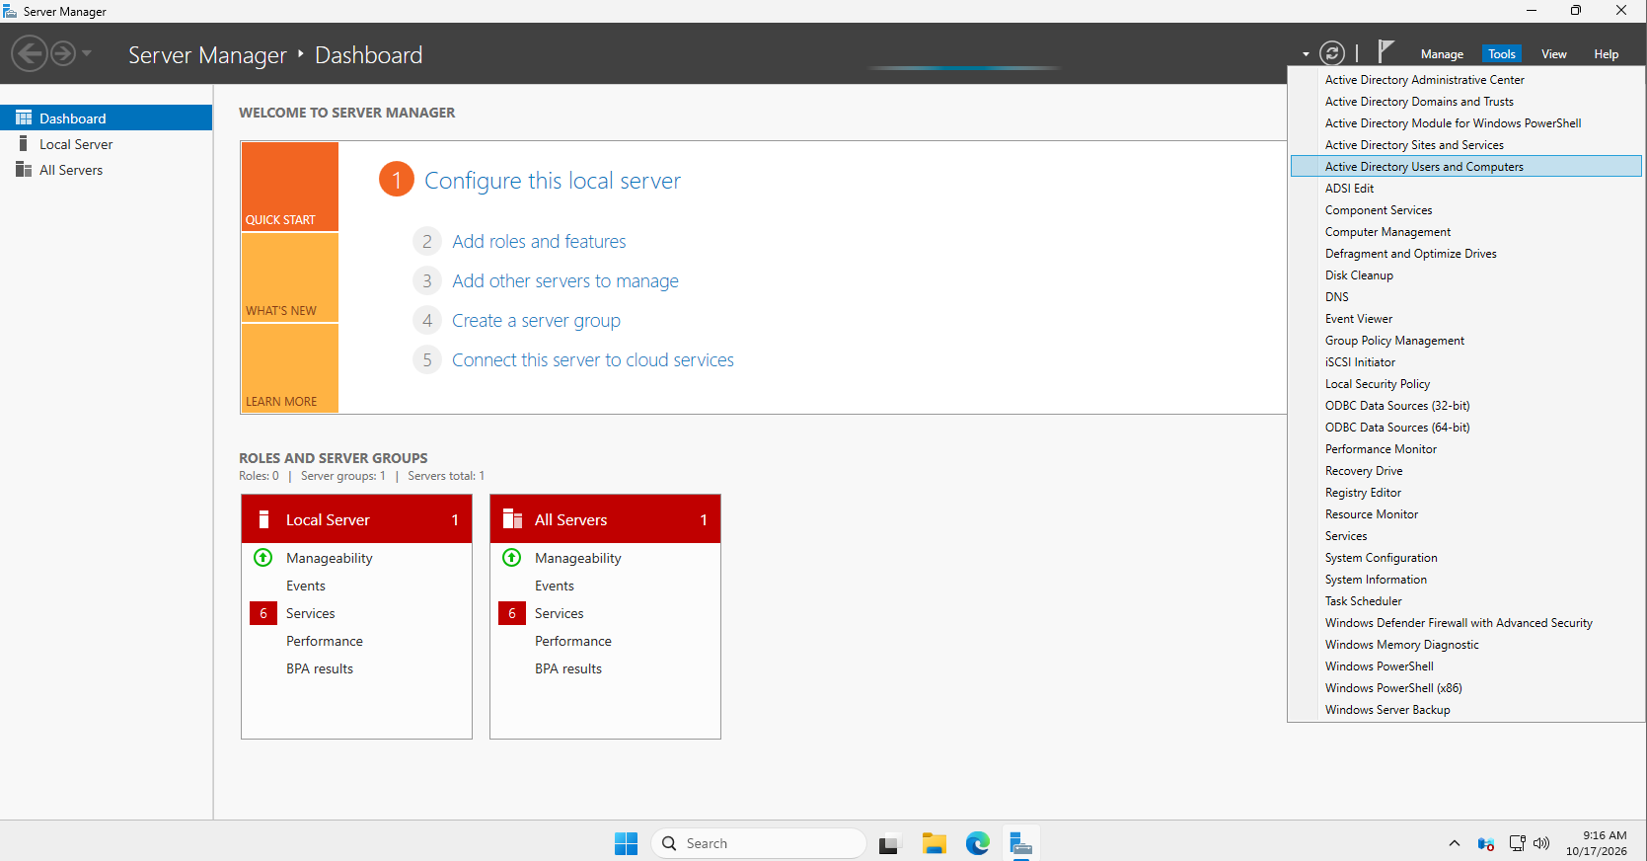
- Expand the domain.
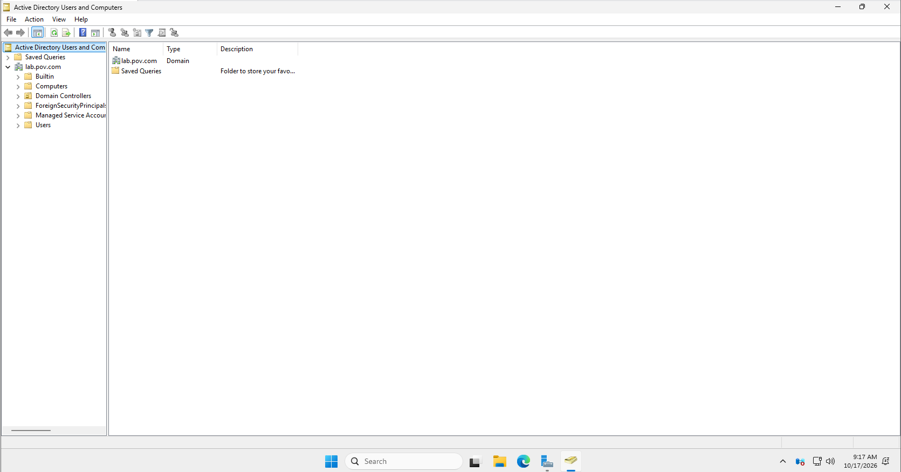
- Right-click the appropriate users container or organizational unit.
- Select New → User
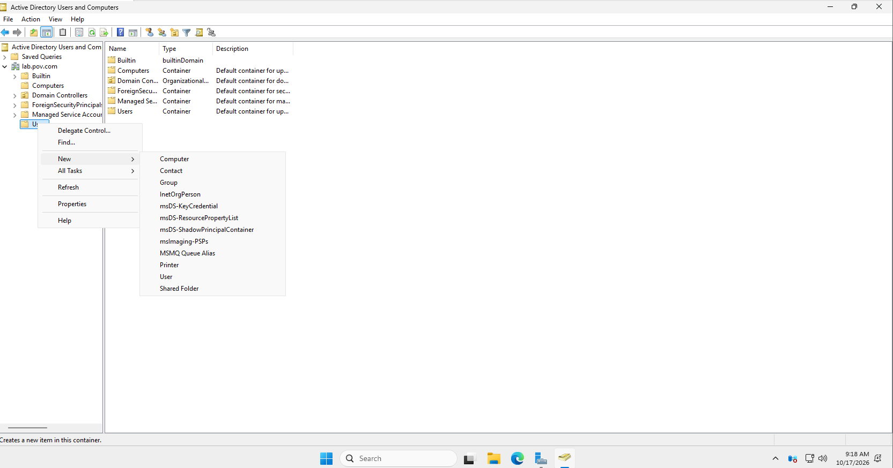
- Create a test account named student1.
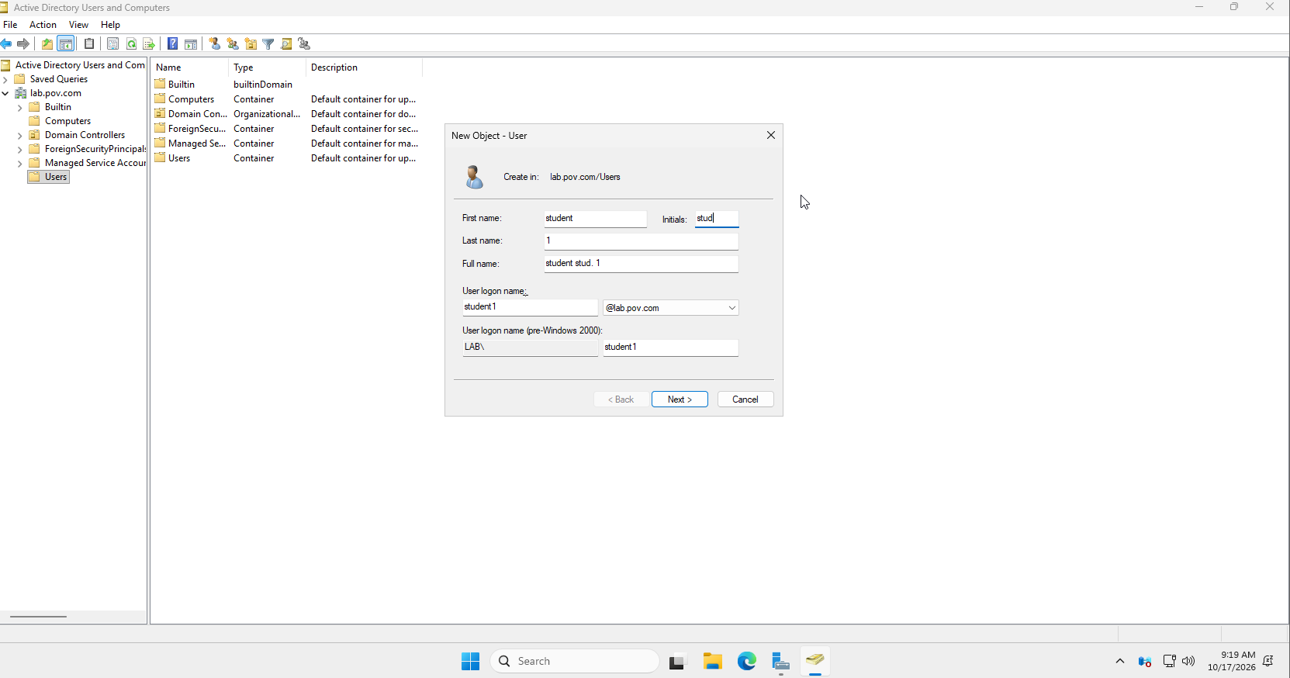
- Set a password and complete the wizard.
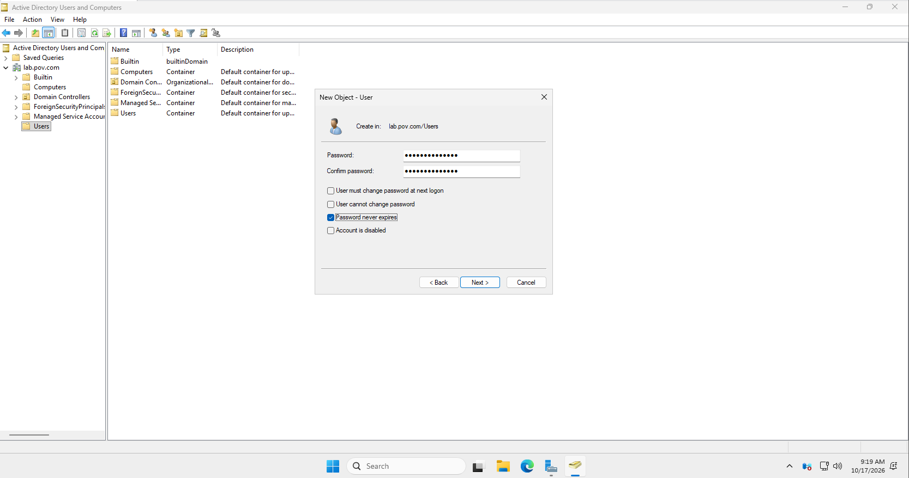
- Confirm that the user account appears in the domain.
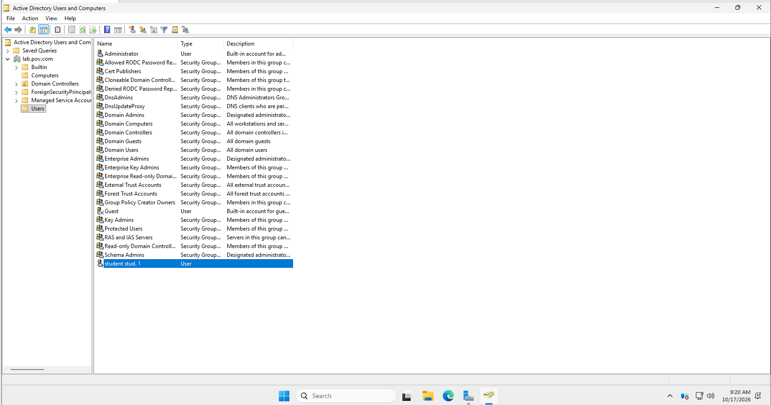
This account will be used to test access to the published application.
Step 5: Install Remote Desktop Services
- Open Server Manager.
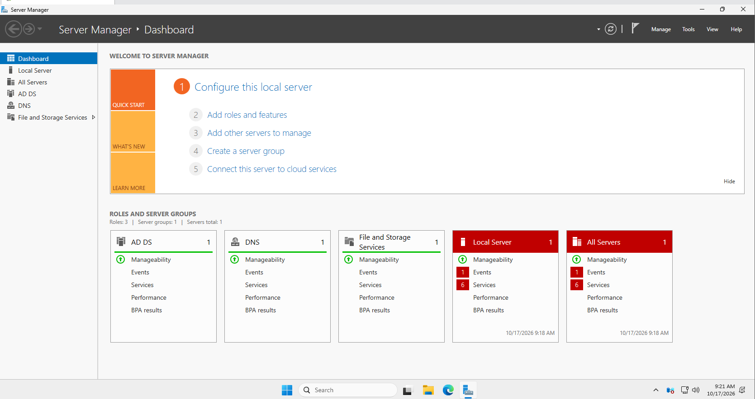
- Select Manage → Add Roles and Features.
- Select Remote Desktop Services installation.
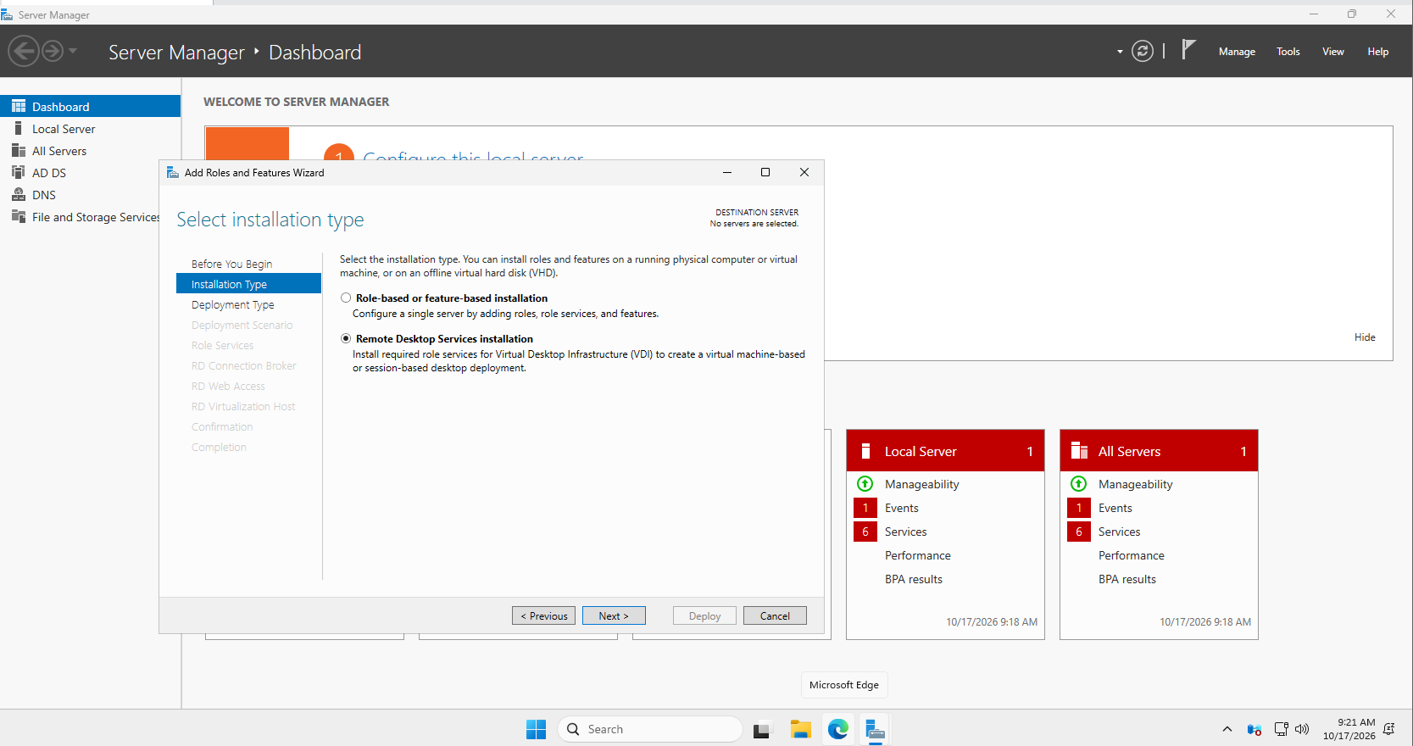
- Choose Standard deployment.
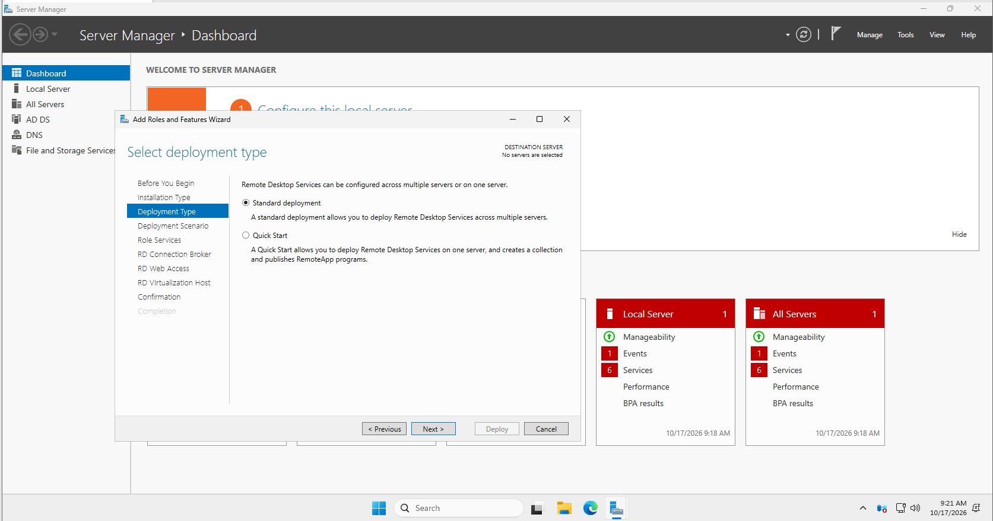
- Select Session-based desktop deployment.
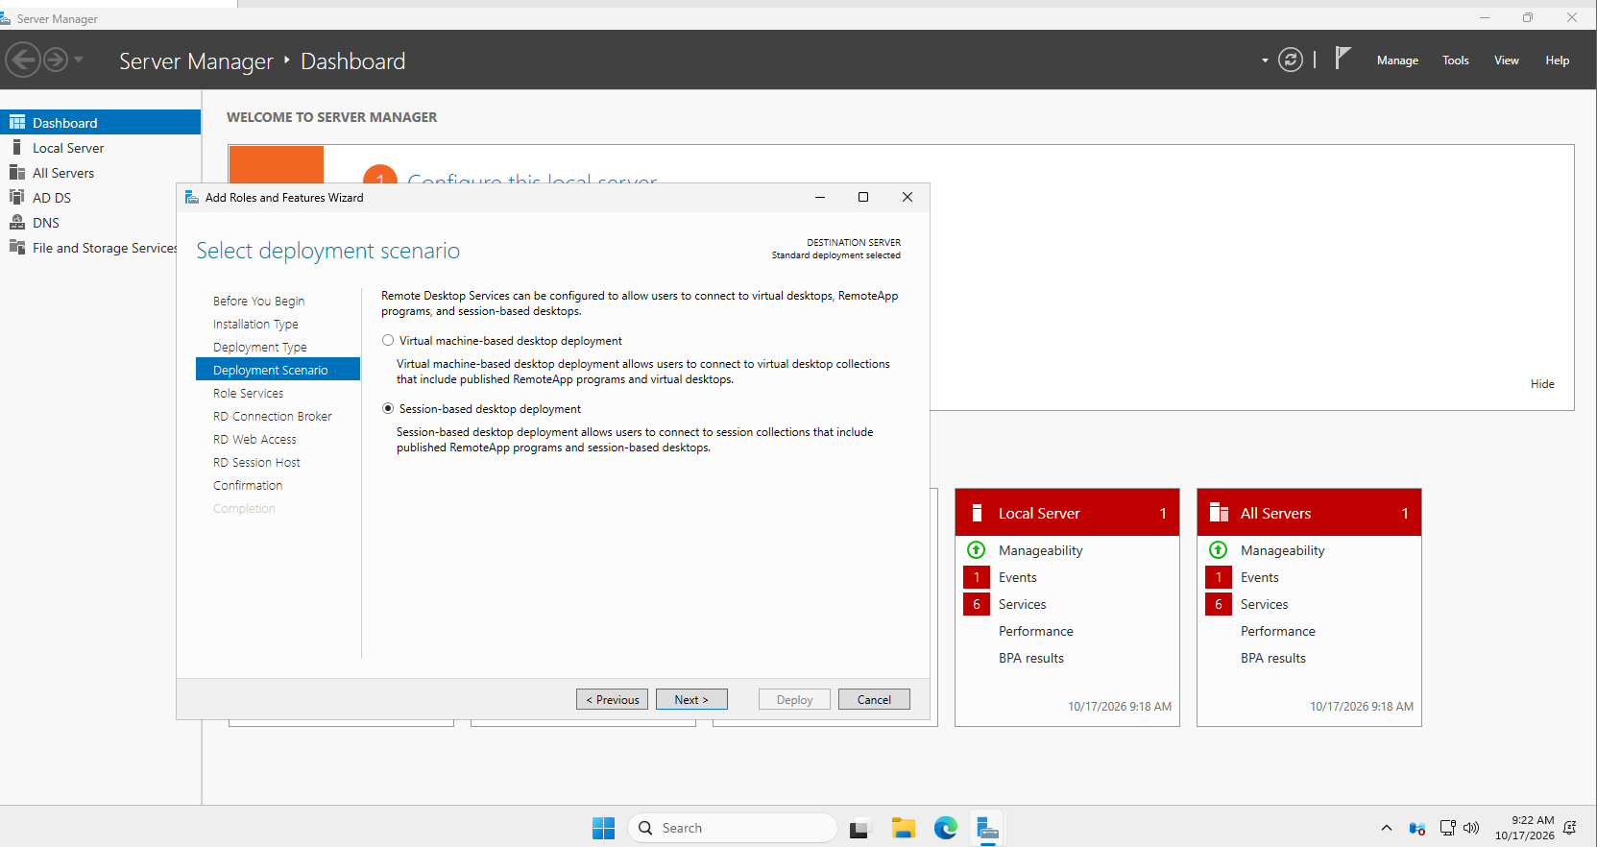
- Assign the available server to the following roles:
  - RD Connection Broker
  - RD Web Access
  - RD Session Host
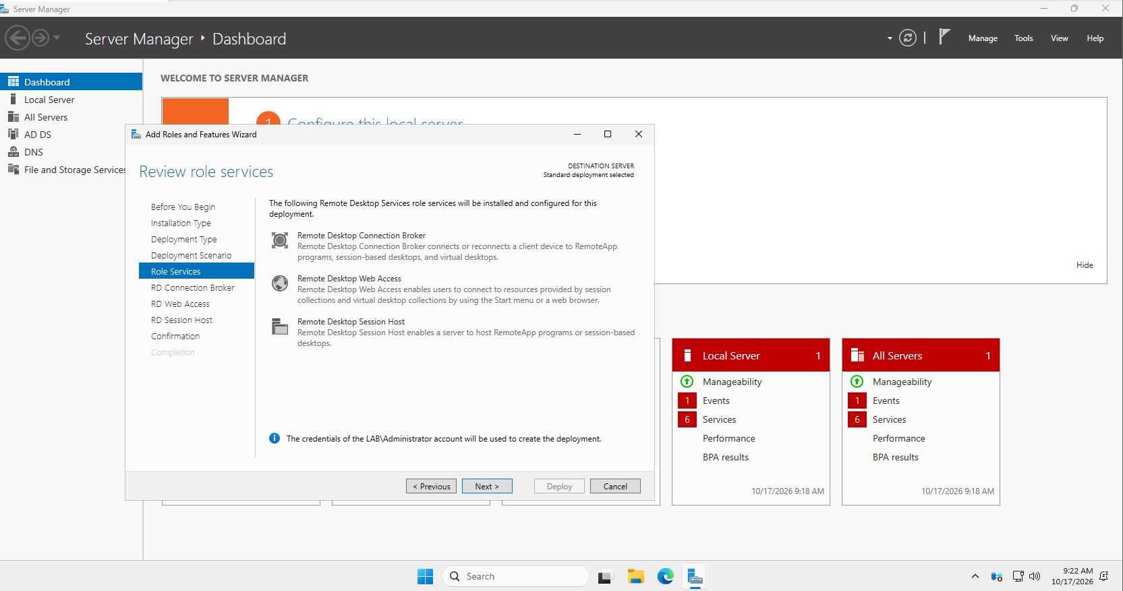
- Review the selected roles and confirm the configuration.
- Check the option “Restart the destination server automatically if required” and then click Deploy.
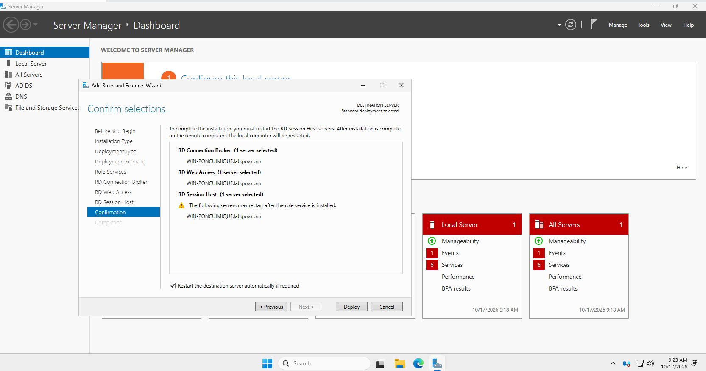
- Wait for the deployment to complete.
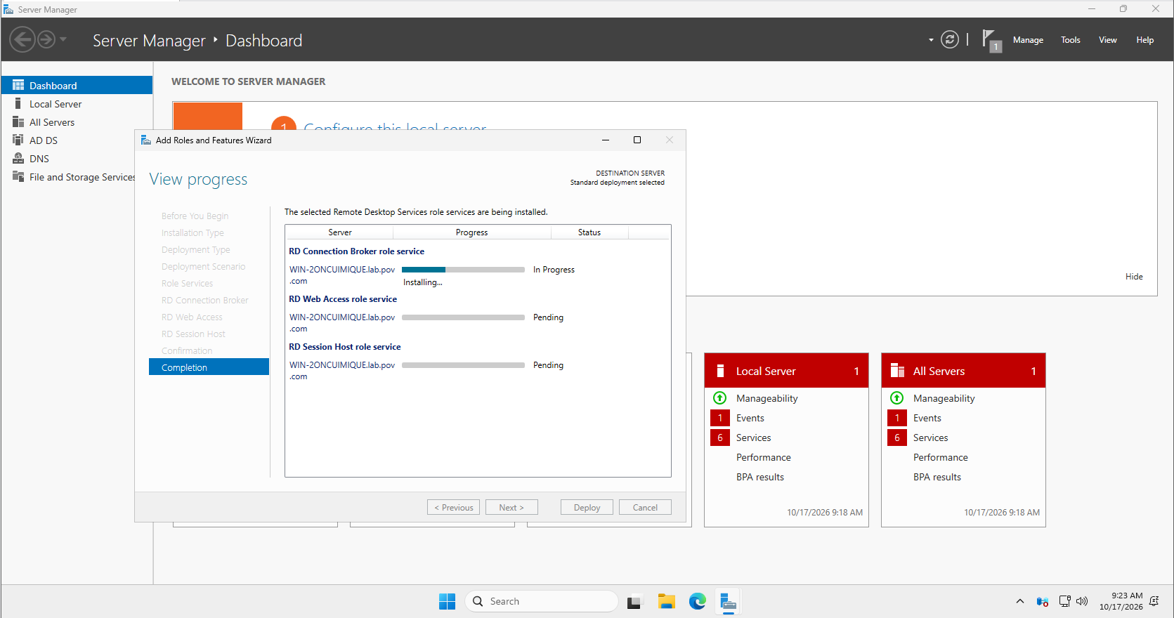

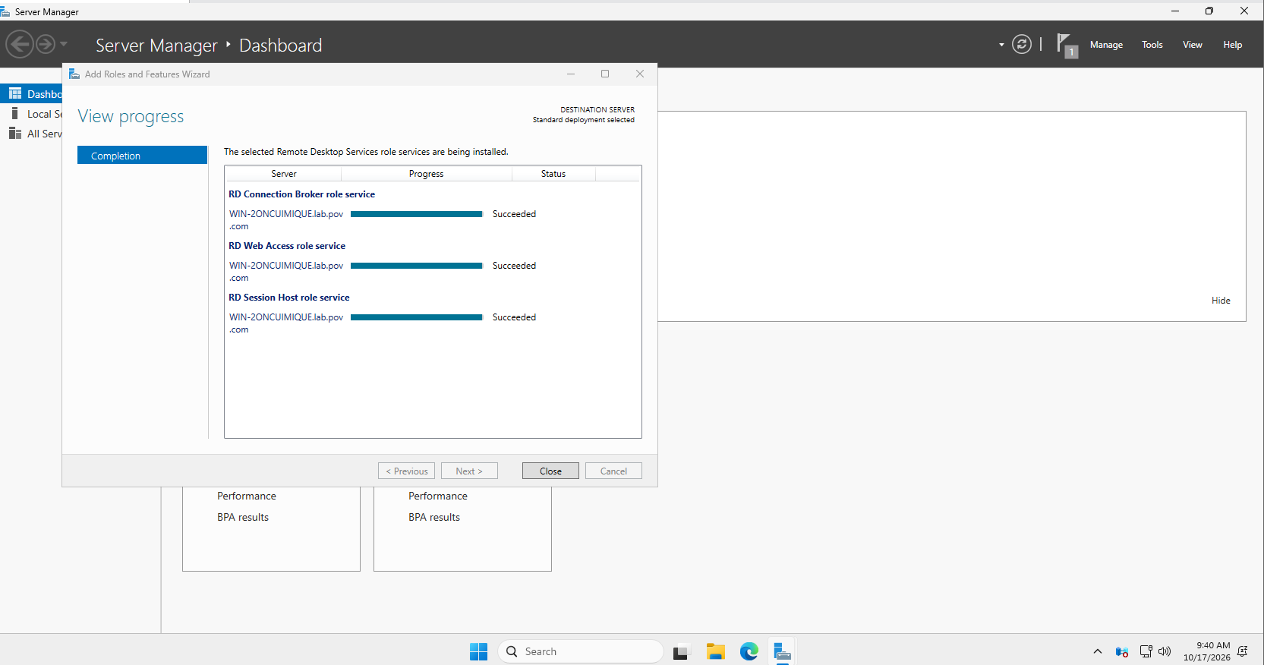
After installation, the Windows Server might restart. You will be presented at the login screen with the “Other User” login option.
Login into your Adminstrator account in the following manner:
Username: LAB\Administrator
Password: <password>
After logging in, verify that the required RDS roles are displayed in Server Manager.
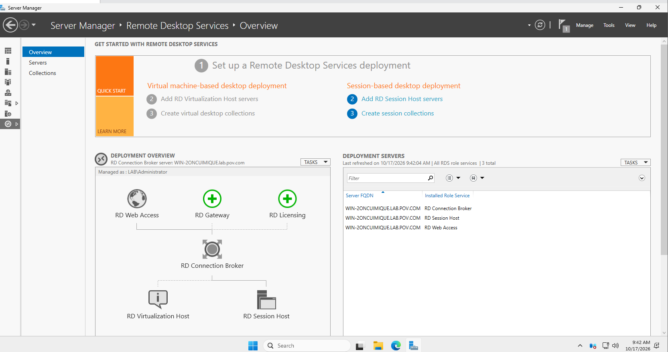
Step 6: Create a Session Collection
A session collection groups the applications and desktops that users can access.
- Open Server Manager.
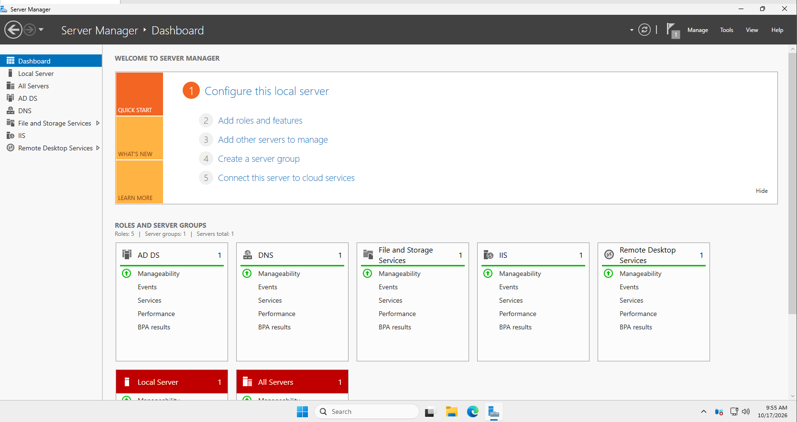
- Select Remote Desktop Services.
- Open the Overview page and verify the deployment.
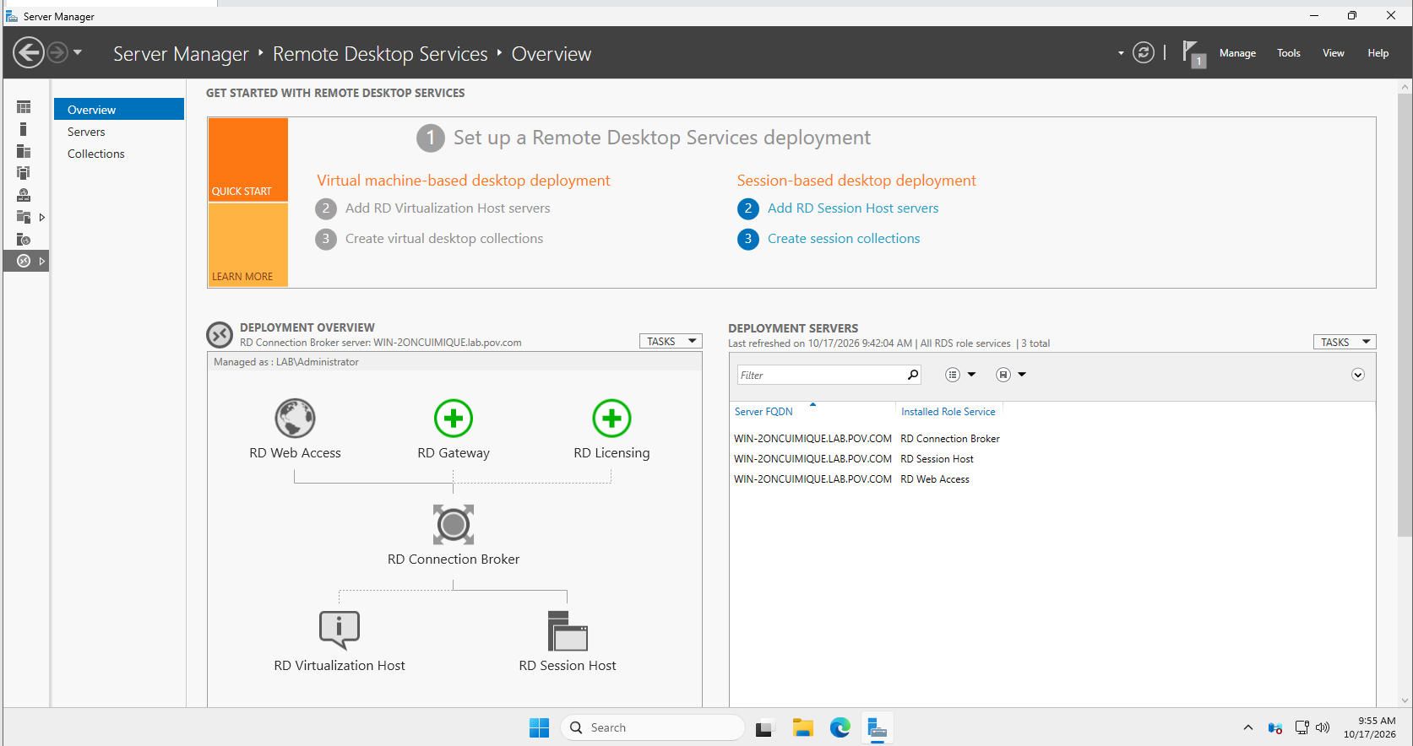
- Select Collections.
- Click Tasks → Create Session Collection.
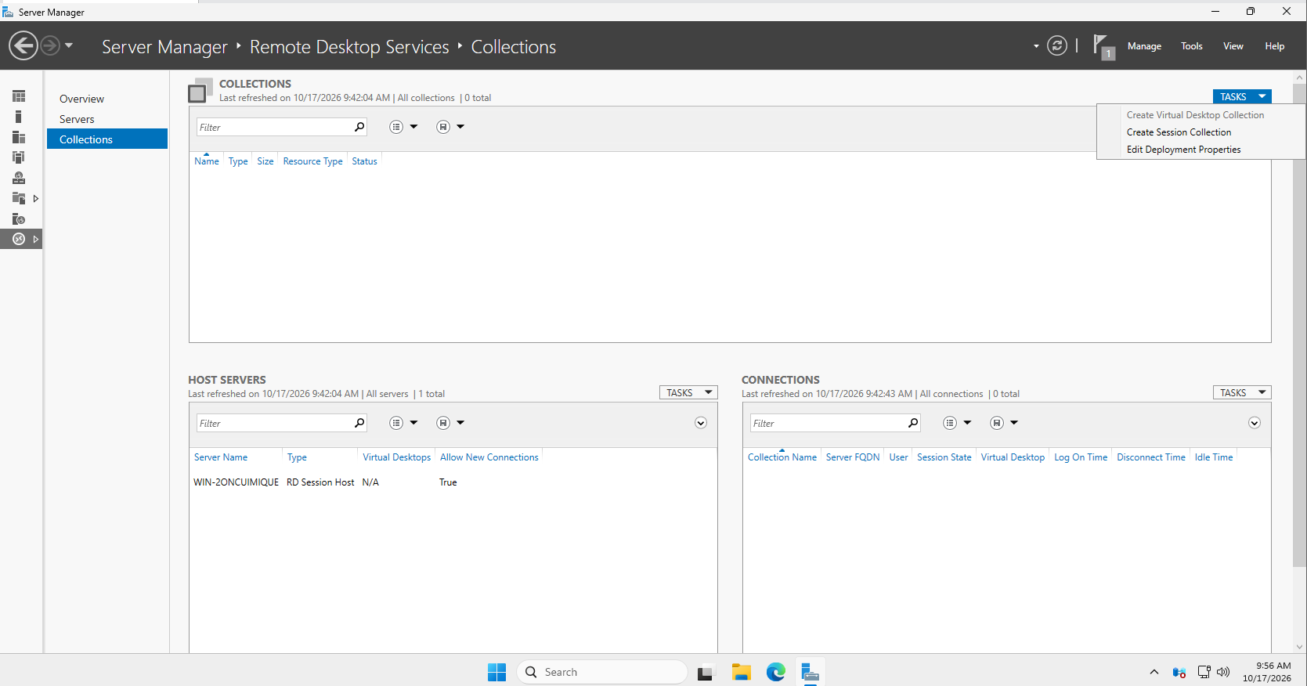
- Enter the collection name RemoteAppCollection.
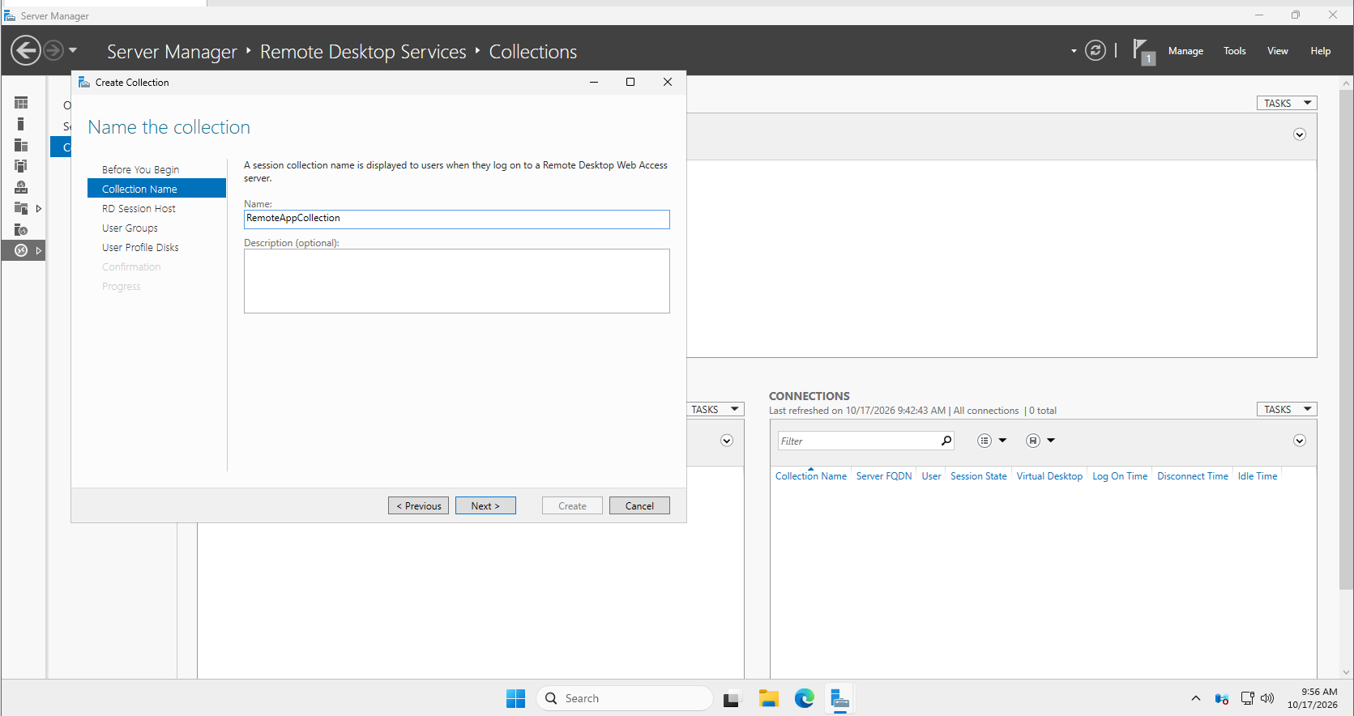
- Select the RD Session Host server.
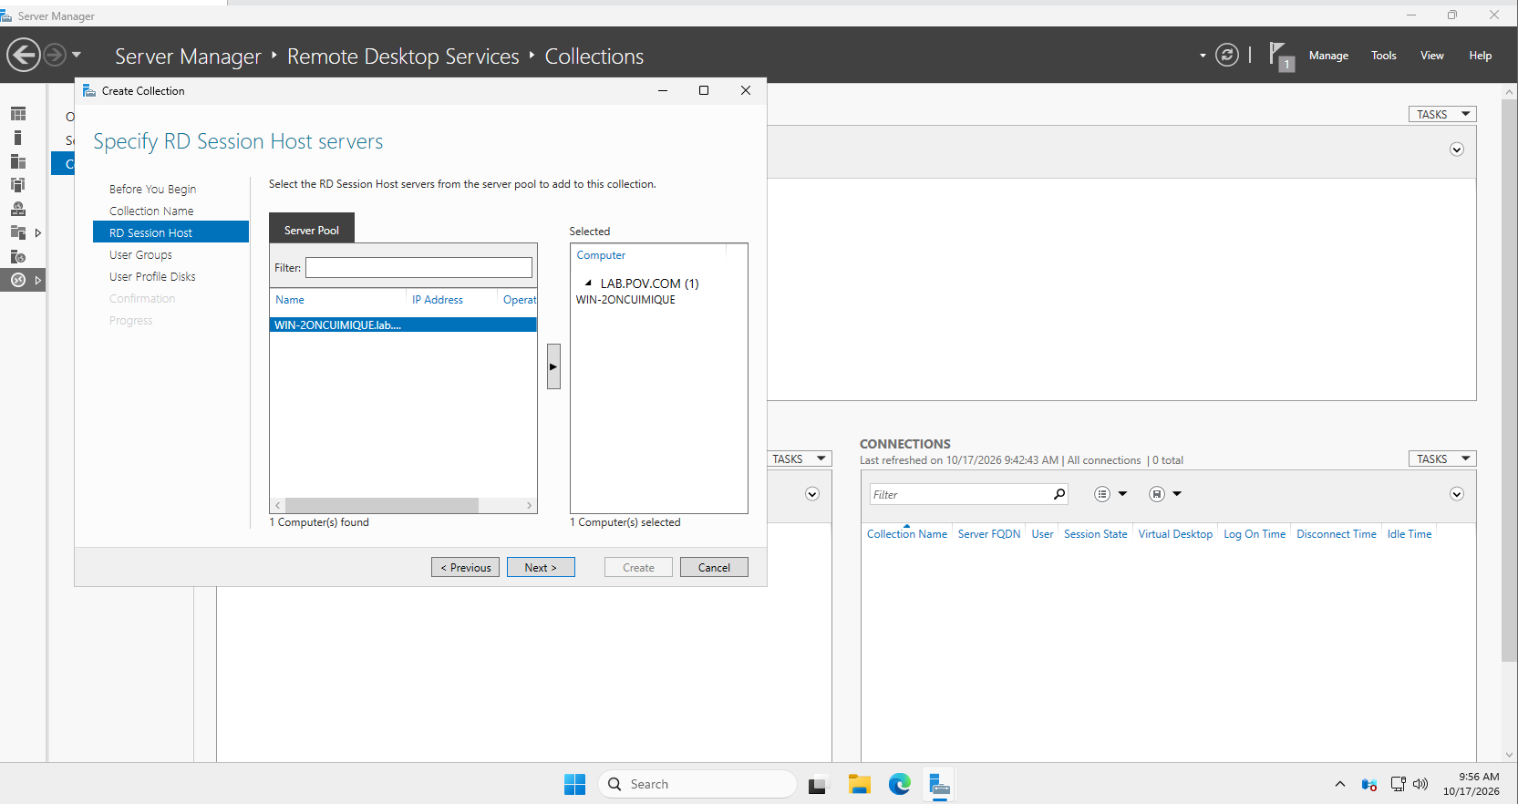
- Specify the user group allowed to access the collection.
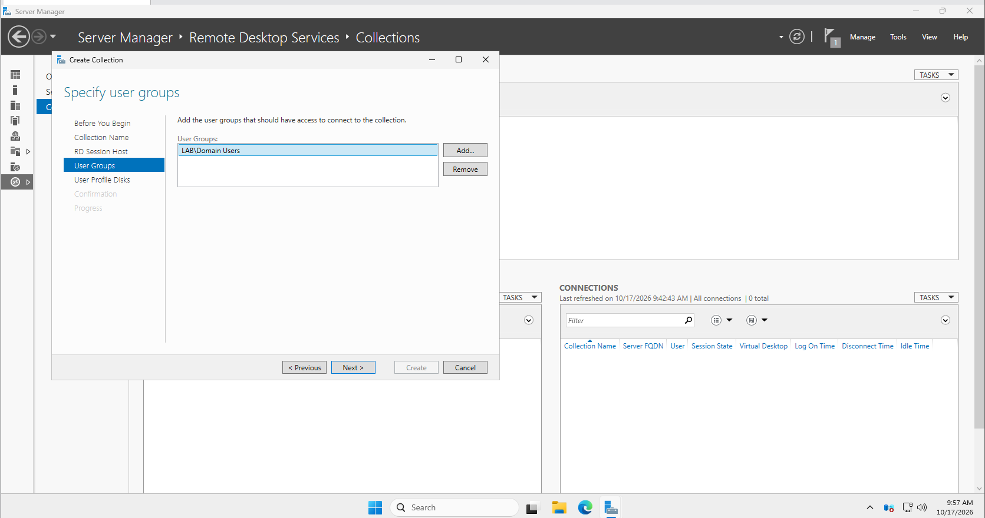
- Complete the wizard and create the collection.
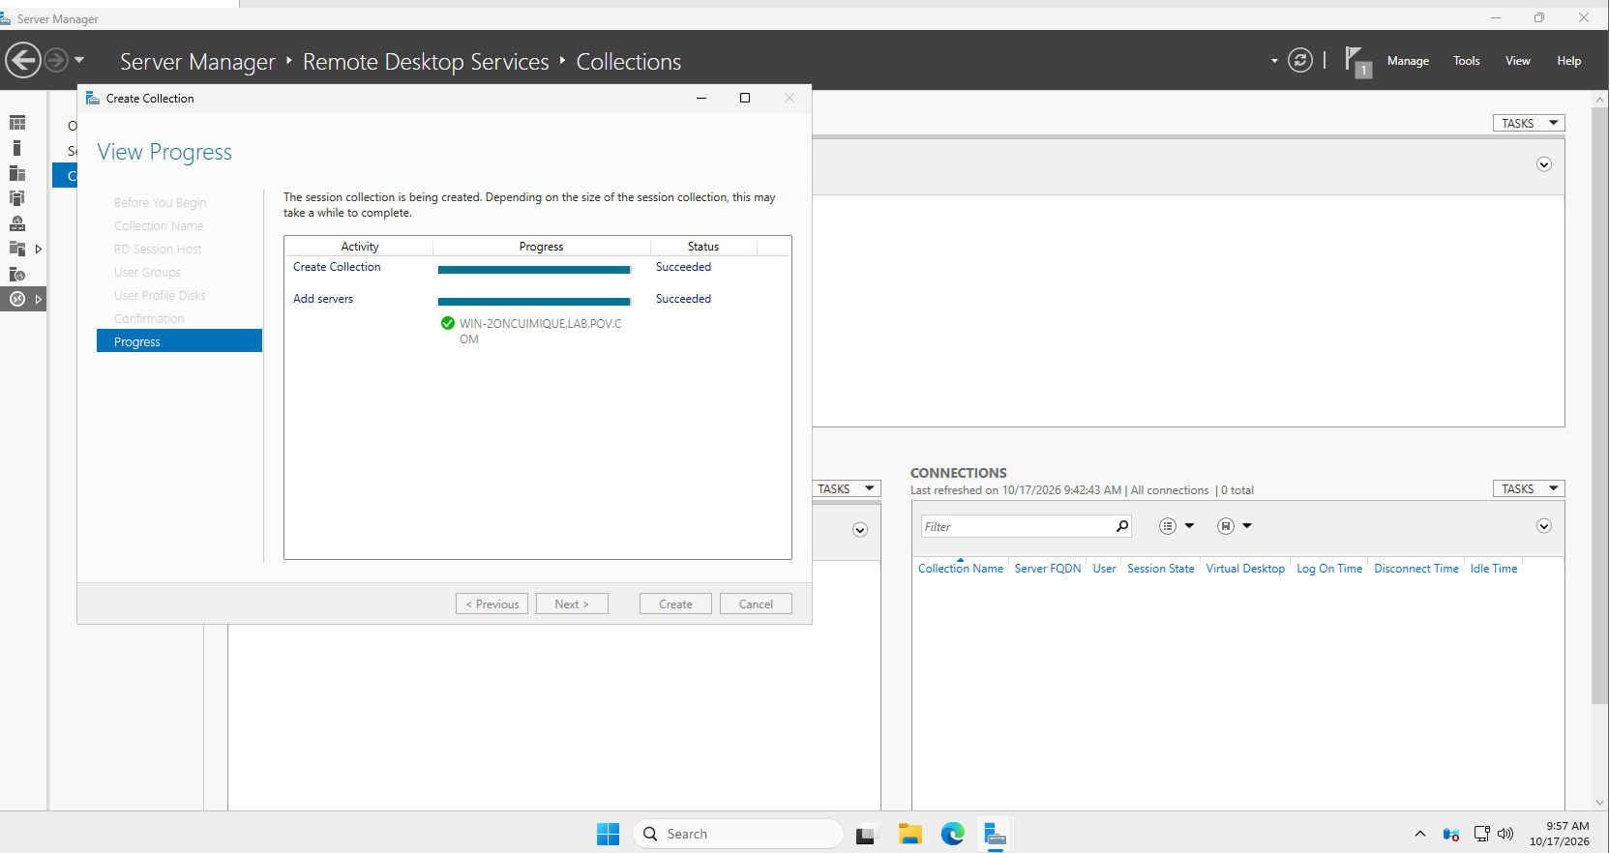
- Verify that RemoteAppCollection appears in the Collections section.
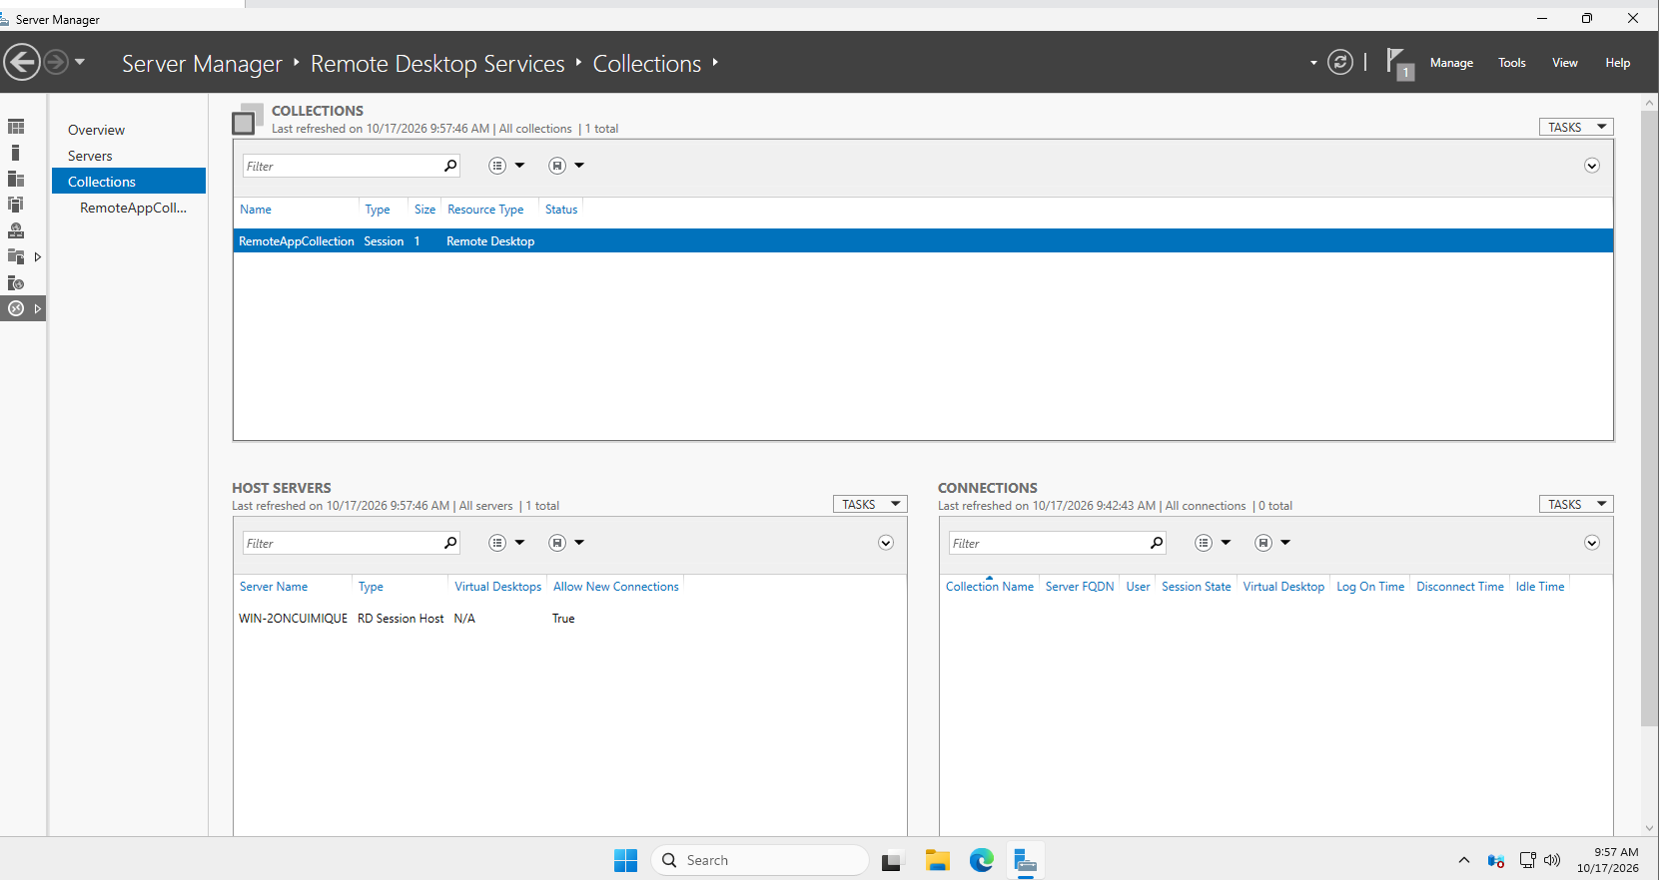
Step 7: Publish an Application Using RemoteApp
In this practical, Notepad will be published as a RemoteApp application.
- Open Server Manager.
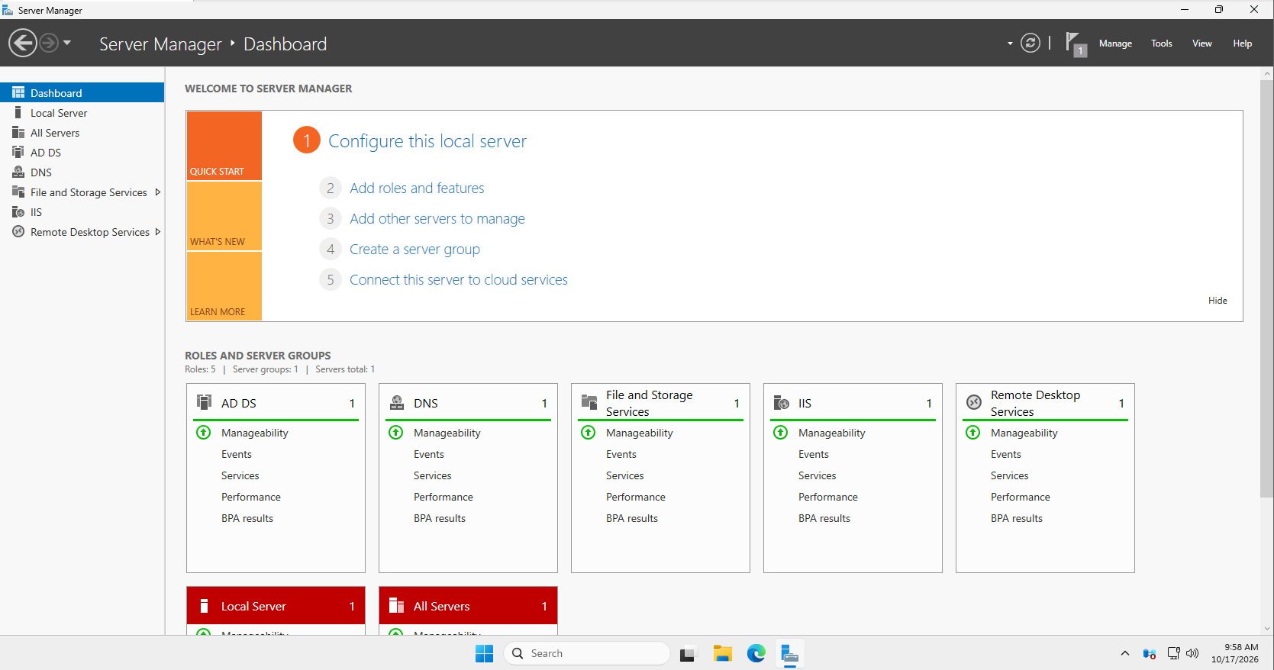
- Navigate to Remote Desktop Services → Collections.
- Select RemoteAppCollection.
- Locate the RemoteApp Programs section.
- Select Tasks → Publish RemoteApp Programs.
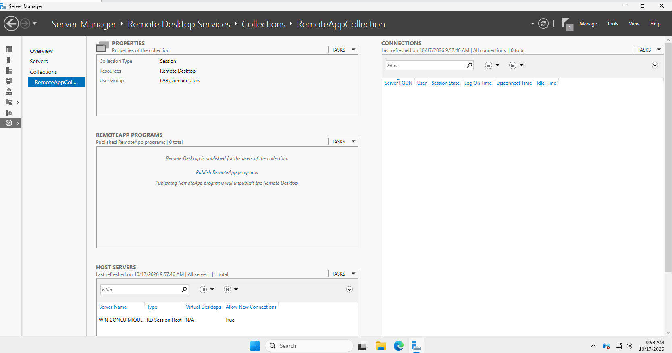
- Select Notepad from the list of available applications.
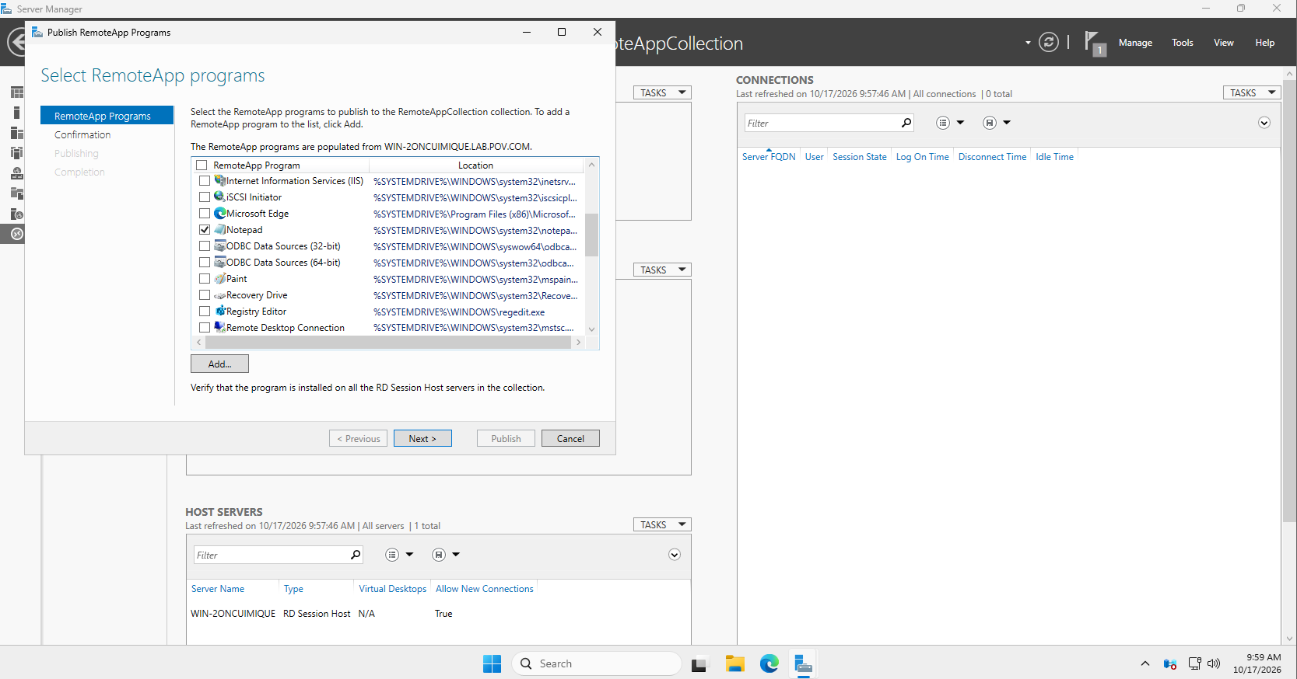
- Click Next and then Publish.
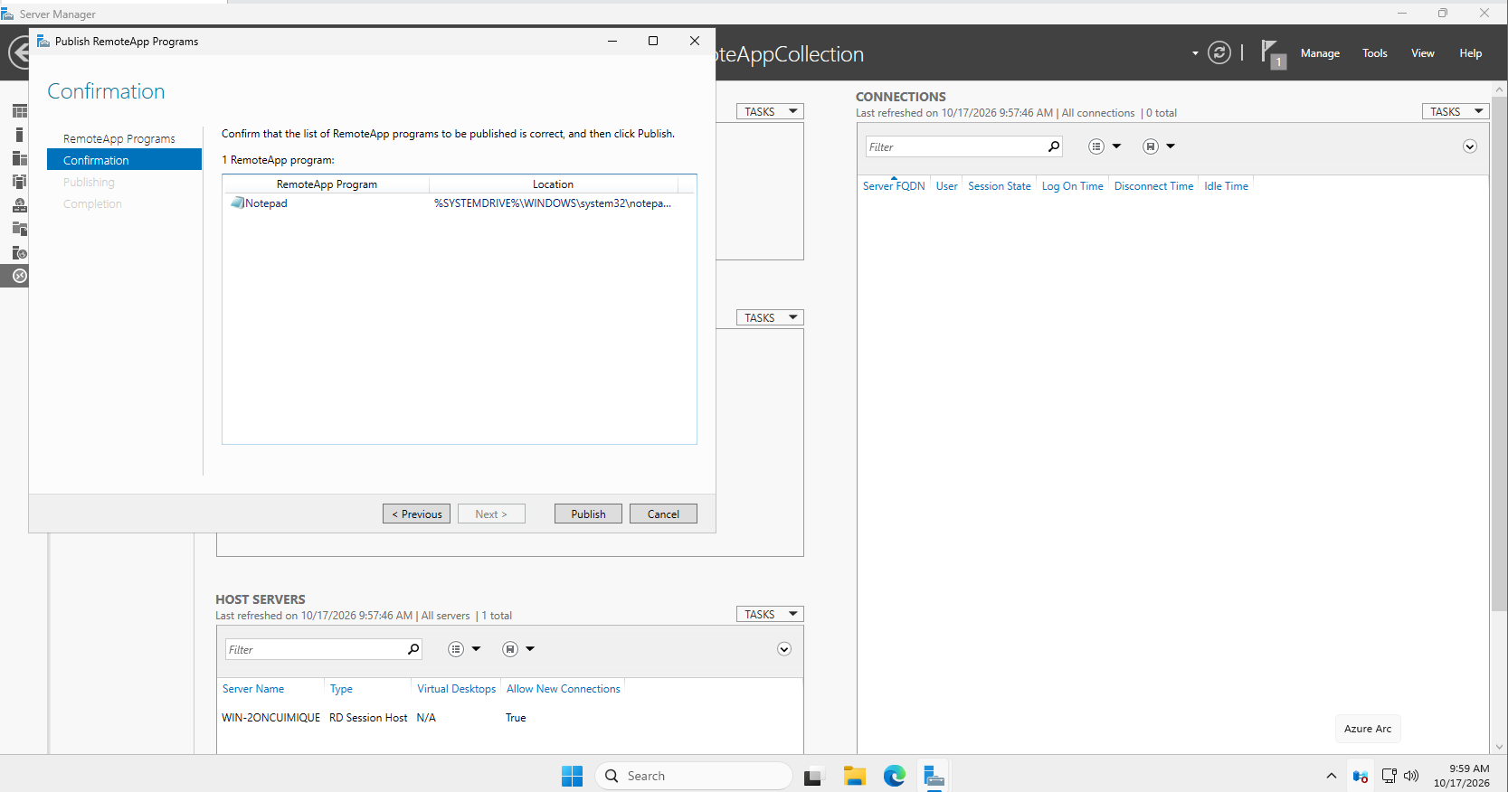
- Confirm that Notepad appears in the published RemoteApp Programs list.
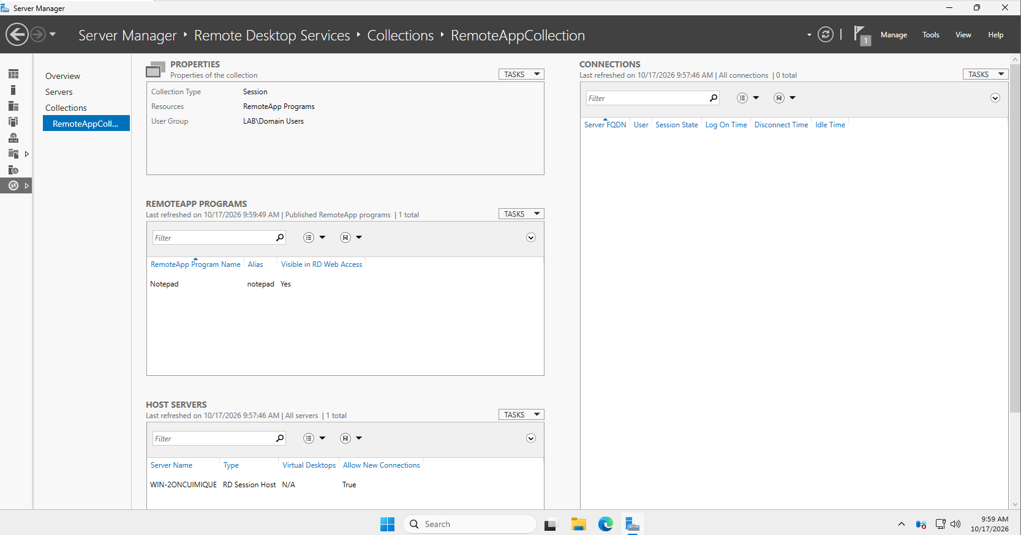
The application is now published for authorized users.
Step 8: Access RD Web Access
- On the Windows 11 host, open a web browser.
- Enter the RD Web Access URL in the following format:
https://<server-ip-address>/RDWeb
- For example, if the server's IP address is 192.168.1.10, try:
https://192.168.1.10/RDWeb

Replace the example address with the actual address of the server.
- If the page does not open, verify the RD Web Access role, network connectivity, HTTPS configuration, and name resolution.
- If a certificate warning appears in the lab, verify that the address belongs to your own server and check the certificate configuration.
- Sign in using the authorized domain account, for example:
LAB\student1
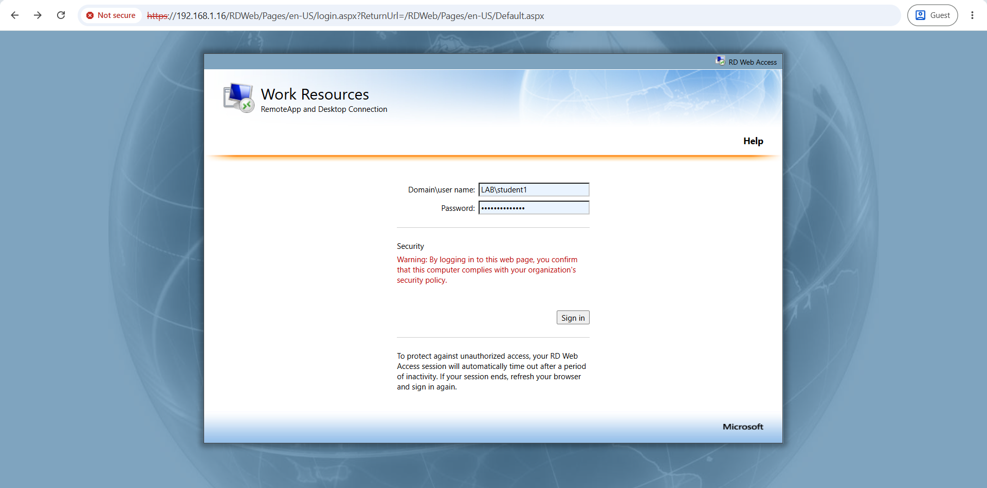
Replace LAB with the actual domain's NetBIOS name.
- Verify that the published Notepad application is displayed in the portal.
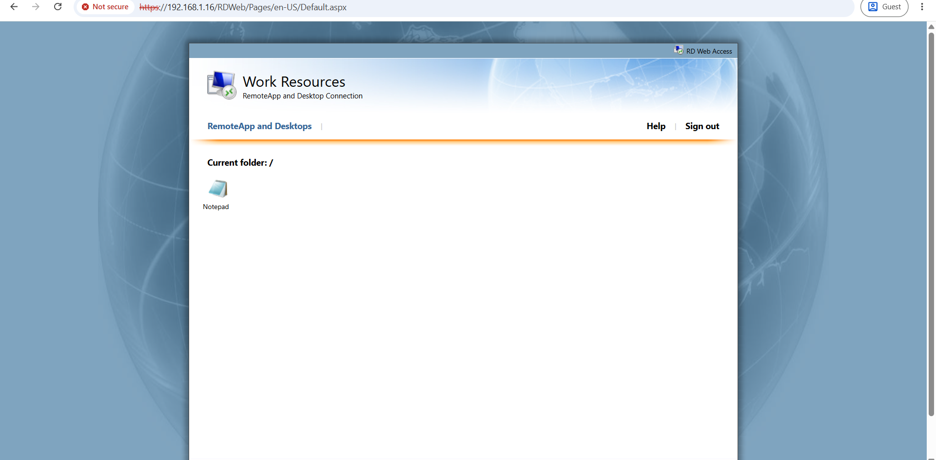
Step 9: Launch and Test the RemoteApp
- In the RD Web Access portal, click the published Notepad application.
- If prompted, download or open the Remote Desktop connection file.
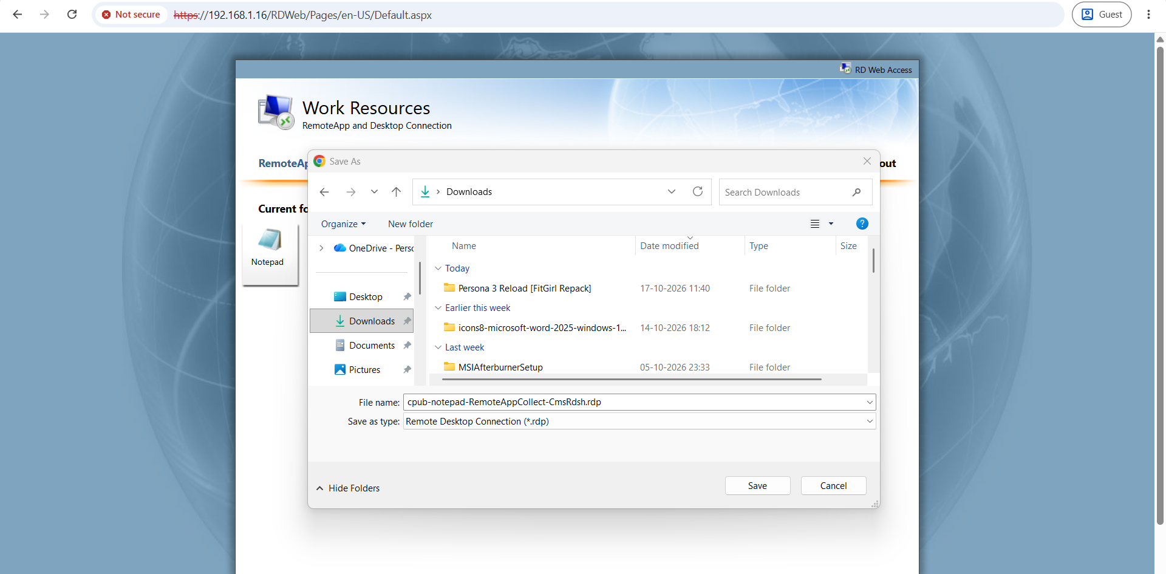
- Launch the connection using the Windows Remote Desktop client.
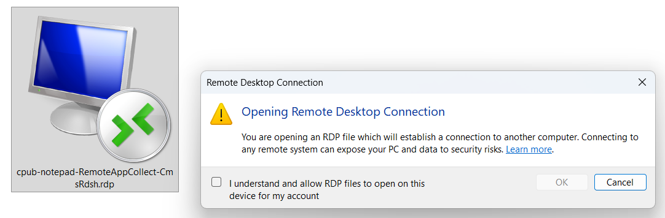

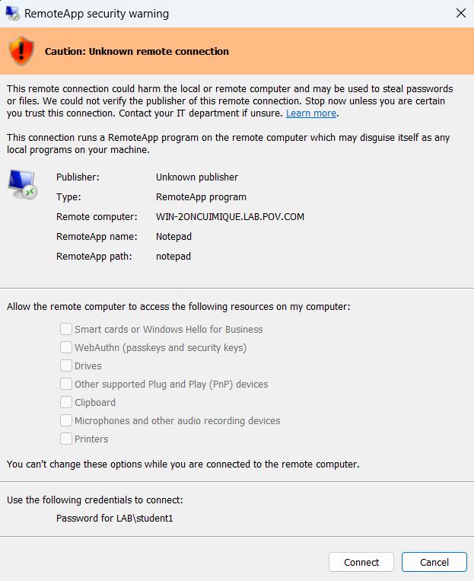
- Enter the required credentials if prompted.
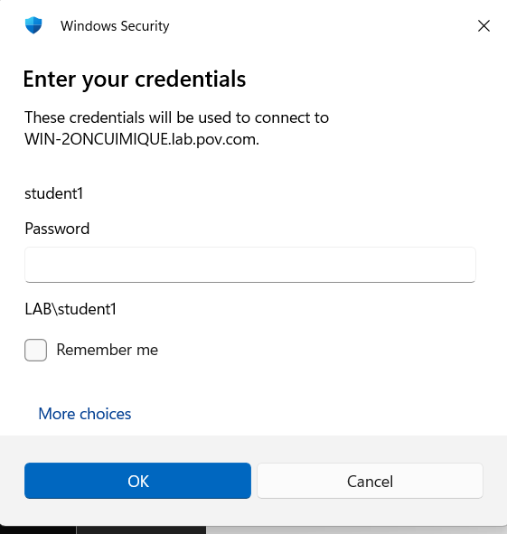

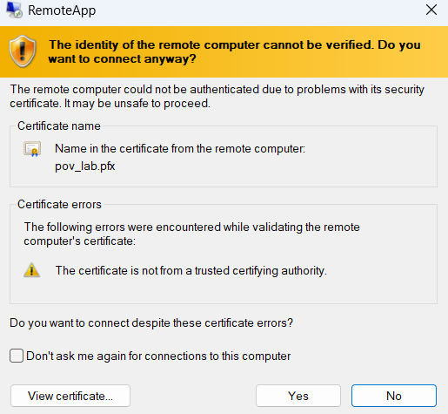
- Wait for Notepad to open.
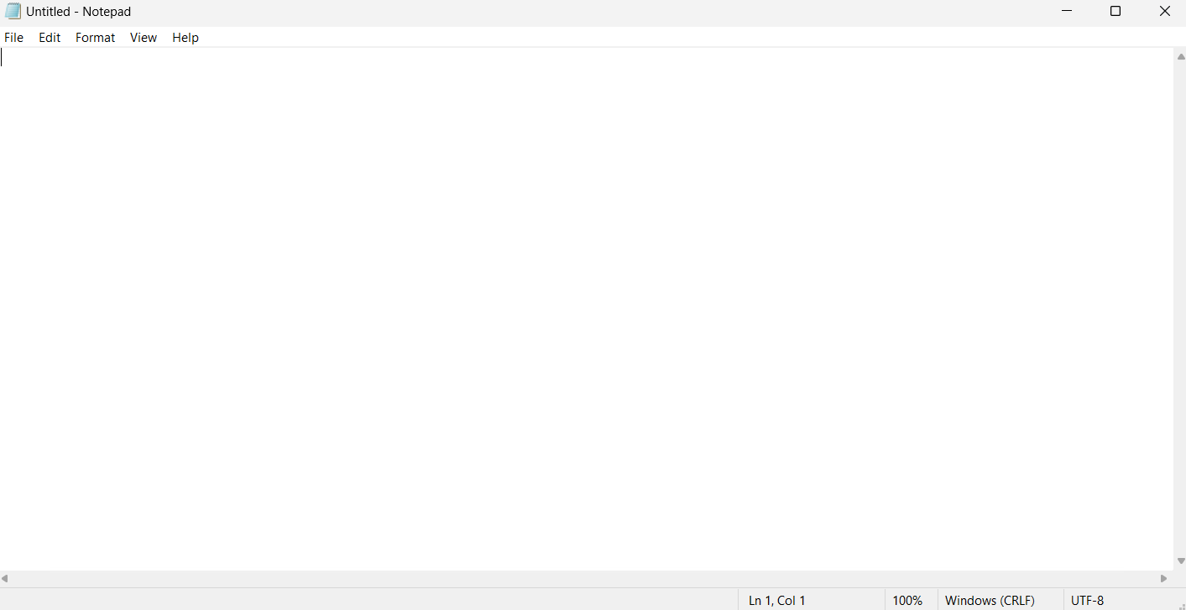
- Type a test message in Notepad.
- Verify that the application responds correctly.
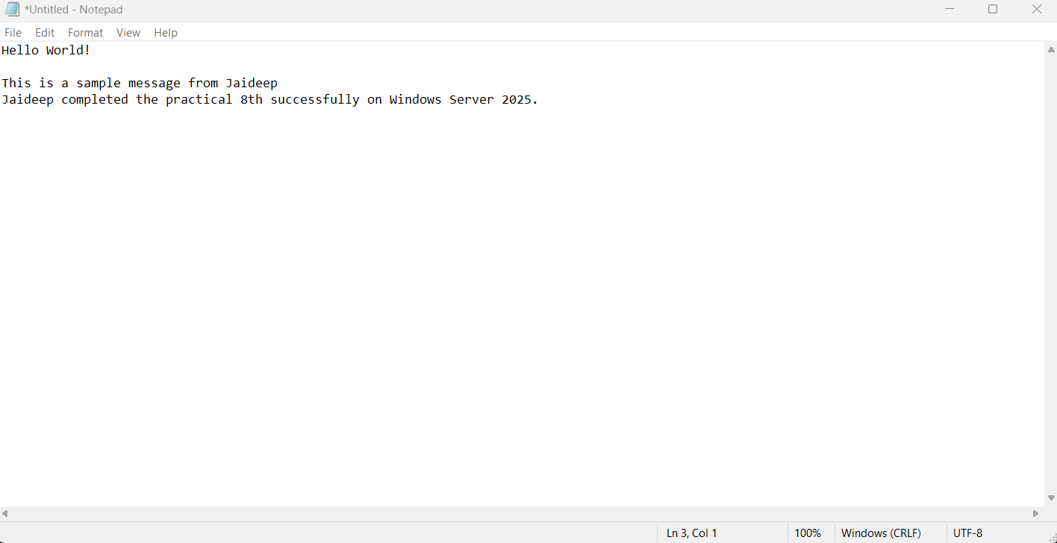
- Close Notepad and end the remote session.
The application window should appear on the Windows 11 client, while the application itself runs on the Windows Server 2025 VM.
5. Testing and Observation
Test | Expected Result
Server connectivity | The Windows 11 host can communicate with the server
RDS deployment | Required RDS roles are installed
Session collection | RemoteAppCollection is created successfully
Application publishing | Notepad appears in the published applications list
RD Web Access | The web portal opens successfully
User authentication | The authorized user can sign in
RemoteApp execution | Notepad opens and accepts input
Session termination | The remote application session can be closed
6. Troubleshooting
Problem | Possible Solution
RD Web Access page does not open | Verify the server address, RD Web Access role, network connectivity, and HTTPS configuration
Server name cannot be resolved | Check DNS settings or configure name resolution
User cannot sign in | Verify the domain credentials and collection permissions
Notepad is not displayed | Check whether the application is published and the user is authorized
RemoteApp fails to launch | Check the RDS deployment status, certificates, client connectivity, and event logs
Licensing warning appears | Verify RDS licensing configuration and applicable licensing requirements
Remote connection fails | Verify firewall rules, the virtual network, and the Remote Desktop connection settings

Note: RDS deployments may require additional certificate and licensing configuration.
7. Result
Remote Desktop Services was configured on Windows Server 2025. A session collection was created, Notepad was published as a RemoteApp application, and RD Web Access was used to access the published application remotely from the Windows 11 host.

